ADVANCED DATA STRUCTURES - using C

***INDEX***

|  |  |  |
| --- | --- | --- |
| ***PNo*** | ***Program*** | ***Page No*** |
| ***1*** | ***Merge 2 Sorted array*** | ***3*** |
| ***2*** | ***Linear search implementation*** | ***7*** |
| ***3*** | ***Binary search implementation*** | ***9*** |
| ***4*** | ***Stack Implementation*** | ***11*** |
| ***5*** | ***Linear Queue implementation*** | ***14*** |
| ***6*** | ***Circular Queue Implementation*** | ***16*** |
| ***7*** | ***Array insertion*** | ***19*** |
| ***8*** | ***Array deletion*** | ***21*** |
| ***9*** | ***Matrix Addition*** | ***23*** |
| ***10*** | ***Structure Implementation*** | ***25*** |
| ***11*** | ***Linear Linked List implementation*** | ***26*** |
| ***12*** | ***Doubly Linked List implementation*** | ***38*** |
| ***13*** | ***Implementation of set operation*** | ***51*** |
| ***14*** | ***Implementation of binary search tree*** | ***56*** |
| ***15*** | ***Implementation of B-tree*** | ***61*** |
| ***16*** | ***Implementation of disjoint set*** | ***66*** |
| ***17*** | ***Balanced Binary search Tree*** | ***70*** |
| ***18*** | ***Max-Heap implementation*** | ***72*** |
| ***19*** | ***Red-Black tree implementation*** | ***75*** |
| ***20*** | ***Implementation of binomial heap*** | ***86*** |
| ***21*** | ***Min Heap implementation*** | ***97*** |
| ***22*** | ***Prim’s Algoritham*** | ***101*** |

***22mca024***

***1 . Merge 2 sorted array***

#include <stdio.h>

void main(){

int array1[100],array2[100],array3[100],size1,size2,size3;

printf("Enter the size of 1st array\n");

scanf("%d",&size1);22mca04822mca04822mca04822mca048

printf("Enter the elements of 1st array\n");

for(int i=0;i<size1;i++)

scanf("%d",&array1[i]);

printf("Enter the size of 2nd array\n");

scanf("%d",&size2);

printf("Enter the elements of 2nd array\n");

for(int i=0;i<size2;i++)

scanf("%d",&array2[i]);

size3=size1+size2;

for(int i=0;i<size1;i++)

array3[i]=array1[i];

for(int i=0;i<size2;i++)

array3[i+size1]=array2[i];

printf("array elements before sorting\n");

for(int i=0;i<size3;i++)

printf("%d \n",array3[i]);

for(int i = 0; i < size3; i++)

{

int temp;

for(int j = i + 1; j < size3; j++)

{

if(array3[i] > array3[j])

{

temp = array3[i];

array3[i] = array3[j];

array3[j] = temp;

}

}

}

printf("array elements after sorting\n");

for(int i=0;i<size3;i++)

printf("%d \n",array3[i]);

}

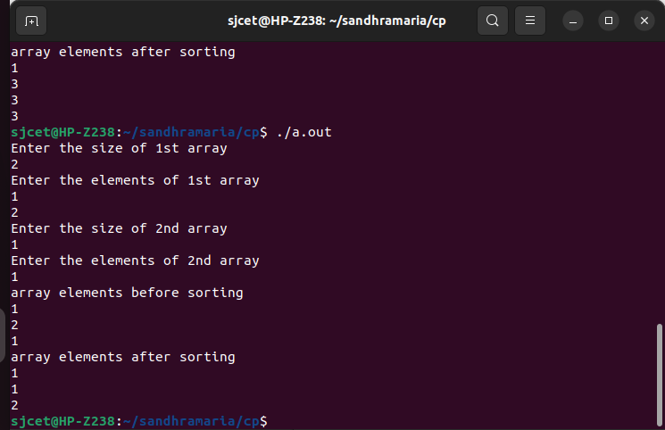

***2.Linear search***

#include<stdio.h>

void main()

{

int a[100],n,s,flag=0;

printf("Enter the array size");

scanf("%d",&n);

printf("Enter the array elements");

for(int i=0;i<n;i++)

{

scanf("%d",&a[i]);

}

printf("Enter the element to be searched\n");

scanf("%d",&s);

for(int i=0;i<n;i++)

{

if(a[i]==s)

{

printf("Element found at position\t %d \n",i+1);

flag=1;

break;

}

}

if(flag==0)

{

printf("Element not found\n");

}

}

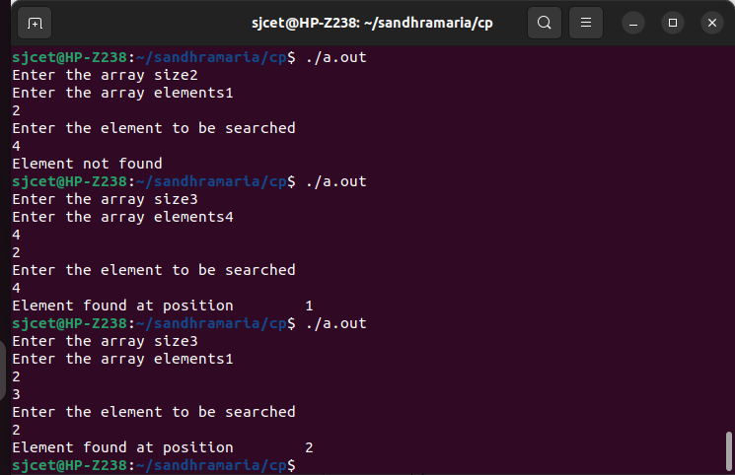

***3. Binary Search***

#include<stdio.h>

void main()

{

int a[100],n,s,first,last,mid,flag;

printf("Enter the array size");

scanf("%d",&n);

printf("Enter the array elements");

for(int i=0;i<n;i++)

{

scanf("%d",&a[i]);

}

printf("Enter the element to be searched\n");

scanf("%d",&s);

first=0;

last=n-1;

flag=0;

while(first<=last)

{

mid=(first+last)/2;

if(s==a[mid])

{

flag=1;

break;

}

else if(s>a[mid])

{

first=mid+1;

}

else

{

last=mid-1;

}

}

if(flag==0)

printf("\n The number is not found");

else

printf("\n The number is found and its position is: %d",mid+1);

}

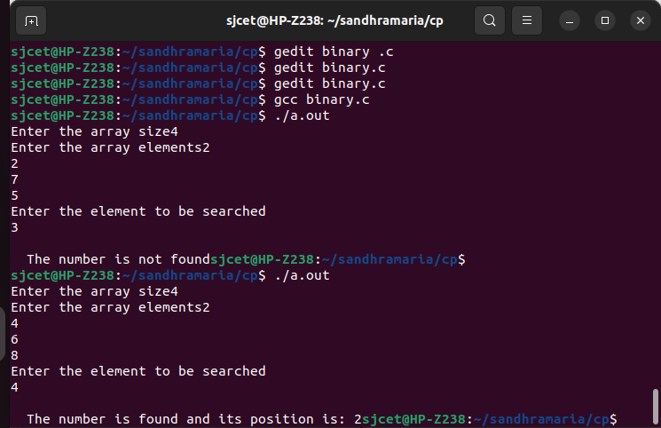

***4.Stack Implementation***

#include<stdio.h>

void push();

void pop();

void peek();

int isfull();

int isempty();

int stack[100],maxsize,top=-1;

void main()

{

printf("Enter the stack size");

scanf("%d",&maxsize);

isempty();

isfull();

peek();

int item;

printf("Enter the element to be inserted ");

scanf("%d",&item);

push(item);

int term;

printf("Enter 1 to delete an element from stack\n ");

scanf("%d",&term);

if(term==1)

pop();

}

int isempty()

{

if(top==-1)

{

printf("The stack is empty\n");

return 0;

}

else

return 1;

}

int isfull()

{

if(top==maxsize)

{

printf("The stack is full\n");

return 0;

}

else

return 1;

}

void peek()

{

printf("The peek of stack is %d\t\n",top);

}

void push(int data)

{

if(isfull()==1)

{

top=top+1;

stack[top]=data;

printf("The element %d is inserted \n",data);

}

}

void pop()

{

if(isempty()==1)

{

printf("\nThe popped element is %d \n",stack[top]);

top=top-1;

}

}

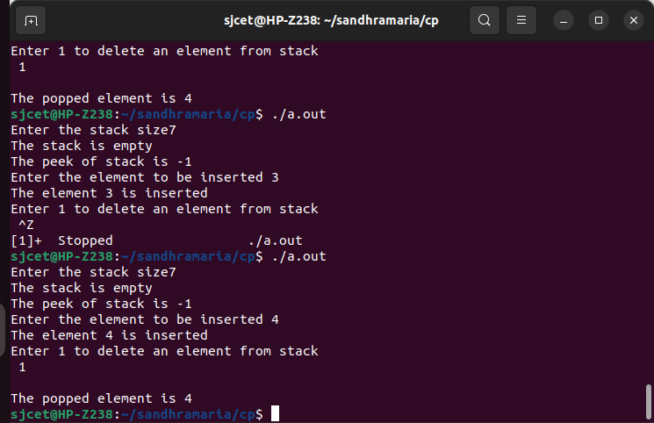

***5. Queue Implementation (linear)***

#include <stdio.h>

#define SIZE 5

void enQueue(int);

void deQueue();

void display();

int items[SIZE], front = -1, rear = -1;

int main() {

deQueue()

enQueue(1);

enQueue(2);

enQueue(3);

enQueue(4);

enQueue(5);

enQueue(6);

display();

deQueue();

display();

return 0;

}

void enQueue(int value) {

if (rear == SIZE - 1)

printf("\nQueue is Full!!");

else {

if (front == -1)

front = 0;

rear++;

items[rear] = value;

printf("\nInserted -> %d", value);

}

}

void deQueue() {

if (front == -1)

printf("\nQueue is Empty!!");

else {

printf("\nDeleted : %d", items[front]);

front++;

if (front > rear)

front = rear = -1;

}

}

void display() {

if (rear == -1)

printf("\nQueue is Empty!!!");

else {

int i;

printf("\nQueue elements are:\n");

for (i = front; i <= rear; i++)

printf("%d ", items[i]);

}

printf("\n");

}

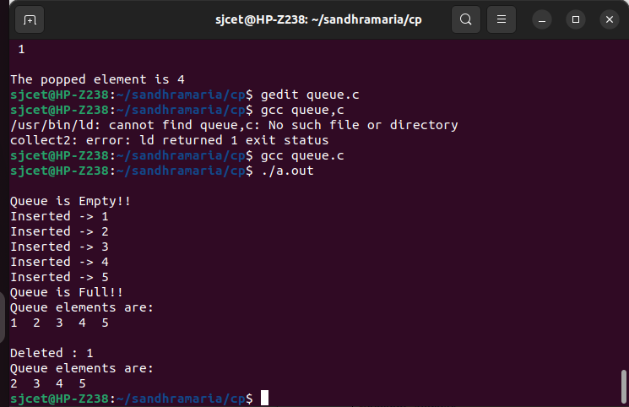

***6. Circular Queue Implementation***

#include <stdio.h>

#define SIZE 5

int items[SIZE];

int front = -1, rear = -1;

int isFull() {

if ((front == rear + 1) || (front == 0 && rear == SIZE - 1)) return 1;

return 0;

}

int isEmpty() {

if (front == -1) return 1;

return 0;

}

void enQueue(int element) {

if (isFull())

printf("\n Queue is full!! \n");

else {

if (front == -1) front = 0;

rear = (rear + 1) % SIZE;

items[rear] = element;

printf("\n Inserted -> %d", element);

}

}

int deQueue() {

int element;

if (isEmpty()) {

printf("\n Queue is empty !! \n");

return (-1);

} else {

element = items[front];

if (front == rear) {

front = -1;

rear = -1;

}

else {

front = (front + 1) % SIZE;

}

printf("\n Deleted element -> %d \n", element);

return (element);

}

}

void display() {

int i;

if (isEmpty())

printf(" \n Empty Queue\n");

else {

printf("\n Front -> %d ", front);

printf("\n Items -> ");

for (i = front; i != rear; i = (i + 1) % SIZE) {

printf("%d ", items[i]);

}

printf("%d ", items[i]);

printf("\n Rear -> %d \n", rear);

}

}

int main() {

deQueue();

enQueue(1);

enQueue(2);

enQueue(3);

enQueue(4);

enQueue(5);

enQueue(6);

display();

deQueue();

display();

enQueue(7);

display();

enQueue(8);

return 0;

}

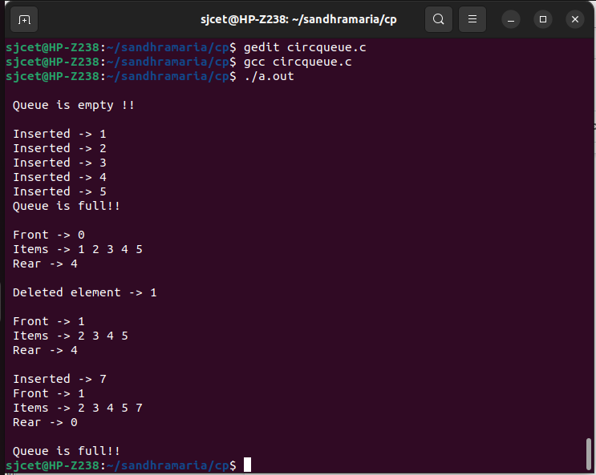

***7. Array Insertion***

#include <stdio.h>

void main(){

int array[100], item, pos,size;

printf("Enter the size of array\n");

scanf("%d",&size);

printf("Enter the elements of array\n");

for(int i=0;i<size;i++)

scanf("%d",&array[i]);

printf("Enter the element to be inserted in the array\n");

scanf("%d",&item);

printf("Enter the position element to be inserted in the array\n");

scanf("%d",&pos);

size=size+1;

for(int i=size-1;i>=pos;i--)

array[i]=array[i-1];

array[pos-1]=item;

printf("new array elements are\n");

for(int i=0;i<size;i++)

printf("%d \n",array[i]);

}

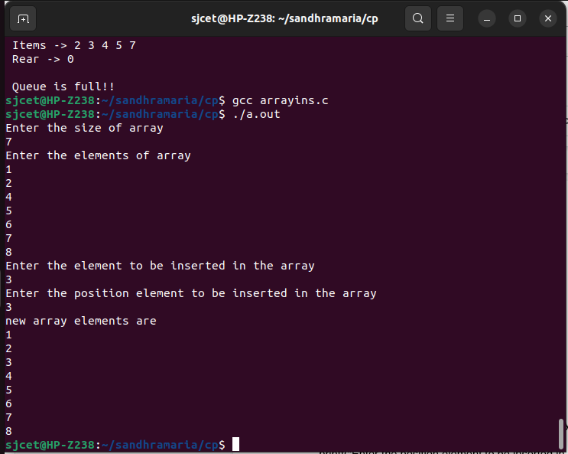

***8. Array deletion***

#include <stdio.h>

void main(){

int array[100],pos,size;

printf("Enter the size of array\n");

scanf("%d",&size);

printf("Enter the elements of array\n");

for(int i=0;i<size;i++)

scanf("%d",&array[i]);

printf("Enter the position element to be deleted in the array\n");

scanf("%d",&pos);

for(int i=pos-1;i<size-1;i++)

array[i]=array[i+1];

printf("array elements after deletion are\n");

for(int i=0;i<size-1;i++)

printf("%d \n",array[i]);

}

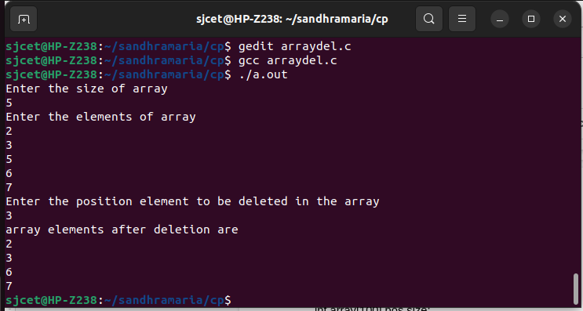

***9. Matrix Addition***

#include <stdio.h>

int main() {

int r, c, a[100][100], b[100][100], sum[100][100], i, j;

printf("Enter the number of rows (between 1 and 100): ");

scanf("%d", &r);

printf("Enter the number of columns (between 1 and 100): ");

scanf("%d", &c);

printf("\nEnter elements of 1st matrix:\n");

for (i = 0; i < r; ++i)

for (j = 0; j < c; ++j) {

printf("Enter element a%d%d: ", i + 1, j + 1);

scanf("%d", &a[i][j]);

}

printf("Enter elements of 2nd matrix:\n");

for (i = 0; i < r; ++i)

for (j = 0; j < c; ++j) {

printf("Enter element b%d%d: ", i + 1, j + 1);

scanf("%d", &b[i][j]);

}

for (i = 0; i < r; ++i)

for (j = 0; j < c; ++j) {

sum[i][j] = a[i][j] + b[i][j];

}

printf("\nSum of two matrices: \n");

for (i = 0; i < r; ++i)

for (j = 0; j < c; ++j) {

printf("%d ", sum[i][j]);

if (j == c - 1) {

printf("\n\n");

}

}

return 0;

}

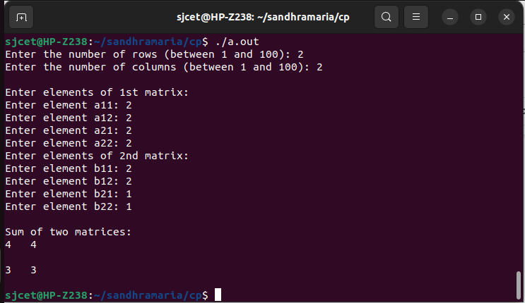

***10. Structure Implimentation***

#include<stdio.h>

#include<string.h>

struct student {

int rollno;

char name[20];

char course[5];

};

struct college {

char name1[7];

struct student s1;

};

void main(){

struct college c1;

c1.s1.rollno=47;

strcpy(c1.s1.name,"Sandhra Maria Saji”);

strcpy(c1.s1.course,"MCA");

strcpy(c1.name1,"SJCET");

printf("College Name : %s\n",c1.name1);

printf("Course Name : %s\n",c1.s1.course);

printf("Student Name : %s\n",c1.s1.name);

printf("roll no : %d\n",c1.s1.rollno);

}

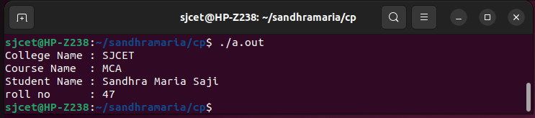

***11. Structure Implementation linear linked list***

#include<stdio.h>

#include<stdlib.h>

struct node

{

int data;

struct node *next;

};

struct node *head;

void insert_begin();

void insert_end();

void insert_middle();

void delete_begin();

void delete_end();

void delete_middle();

void display();

void search();

void main ()

{

int choice=0;

while(choice!=9)

{

printf("\n\nSelect your choice\n");

printf("\n1.Insert in Begining\n2.Insert at End\n3.Insert in between some location\n4.Delete from Beginning\n5.Delete from End\n6.Delete node after specified location\n7.Search for an element\n8.Display\n9.Exit\n");

printf("\nEnter your choice\n");

scanf("\n%d",&choice);

switch(choice)

{

case 1:

insert_begin();

break;

case 2:

insert_end();

break;

case 3:

insert_middle();

break;

case 4:

delete_begin();

break;

case 5:

delete_end();

break;

case 6:

delete_middle();

break;

case 7:

search();

break;

case 8:

display();

break;

case 9:

exit(0);

break;

default:

printf("Invalid Choice \n\n");

printf("NB:Please enter valid choice..");

}

}

}

void insert_begin()

{

struct node*ptr;

int item;

ptr=(struct node*)malloc(sizeof(struct node*));

if(ptr==NULL)

{

printf("\nOVERFLOW");

}

else

{

printf("\nEnter value\n");

scanf("%d",&item);

ptr->data = item;

ptr->next = head;

head = ptr;

printf("\nNode inserted");

}

}

void insert_end()

{

struct node *ptr,*temp;

int item;

ptr = (struct node*)malloc(sizeof(struct node));

if(ptr == NULL)

{

printf("\nOVERFLOW");

}

else

{

printf("\nEnter value?\n");

scanf("%d",&item);

ptr->data = item;

if(head == NULL)

{

ptr -> next = NULL;

head = ptr;

printf("\nNode inserted");

}

else

{

temp = head;

while (temp -> next != NULL)

{

temp = temp -> next;

}

temp->next = ptr;

ptr->next = NULL;

printf("\nNode inserted");

}

}

}

void insert_middle()

{

int i,loc,item;

struct node *ptr, *temp;

ptr = (struct node *) malloc (sizeof(struct node));

if(ptr == NULL)

{

printf("\nOVERFLOW");

}

else

{

printf("\nEnter element value");

scanf("%d",&item);

ptr->data = item;

printf("\nEnter the location after which you want to insert ");

scanf("%d",&loc);

temp=head;

for(i=0;i<loc-2;i++)

{

temp = temp->next;

if(temp == NULL)

{

printf("\ncan't insert\n");

return;

}

}

ptr ->next = temp ->next;

temp ->next = ptr;

printf("\nNode inserted");

}

}

void delete_begin()

{

struct node *ptr;

if(head == NULL)

{

printf("\nList is empty\n");

}

else

{

ptr = head;

head = ptr->next;

free(ptr);

printf("\nNode deleted from the begining\n");

}

}

void delete_end()

{

struct node *ptr,*ptr1;

if(head == NULL)

{

printf("\nlist is empty");

}

else if(head -> next == NULL)

{

head = NULL;

free(head);

printf("\nThe single node of the list deleted\n");

}

else

{

ptr = head;

while(ptr->next != NULL)

{

ptr1 = ptr;

ptr = ptr ->next;

}

ptr1->next = NULL;

free(ptr);

printf("\nDeleted Node from the last\n");

}

}

void delete_middle()

{

struct node *ptr,*ptr1;

int loc,i;

printf("\n Enter the location of the node after which you want to perform deletion \n");

scanf("%d",&loc);

ptr=head;

for(i=0;i<loc;i++)

{

ptr1 = ptr;

ptr = ptr->next;

if(ptr == NULL)

{

printf("\nNo element, can't delete");

return;

}

}

ptr1 ->next = ptr ->next;

free(ptr);

printf("\nDeleted node %d ",loc+1);

}

void search()

{

struct node *ptr;

int item,i=0,flag;

ptr = head;

if(ptr == NULL)

{

printf("\nEmpty List\n");

}

else

{

printf("\nEnter item which you want to search?\n");

scanf("%d",&item);

while (ptr!=NULL)

{

if(ptr->data == item)

{

printf("item found at location %d ",i+1);

flag=0;

}

else

{

flag=1;

}

i++;

ptr = ptr -> next;

}

if(flag==1)

{

printf("Item not found\n");

}

}

}

void display()

{

struct node *ptr;

ptr = head;

if(ptr == NULL)

{

printf("Nothing to print, Empty list");

}

else

{

printf("\nprinting values\n");

while (ptr!=NULL)

{

printf("\n%d",ptr->data);

ptr = ptr -> next;

}

}

}

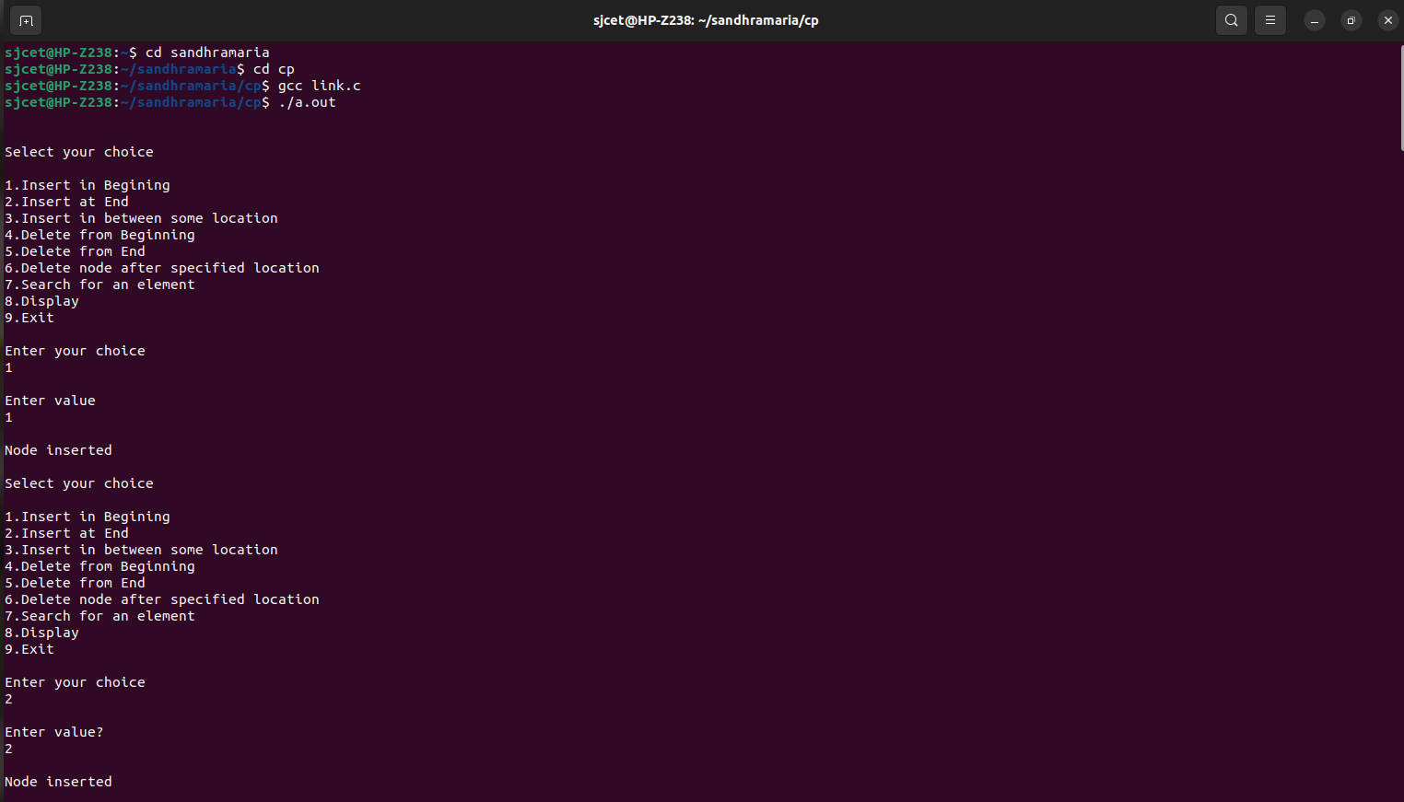

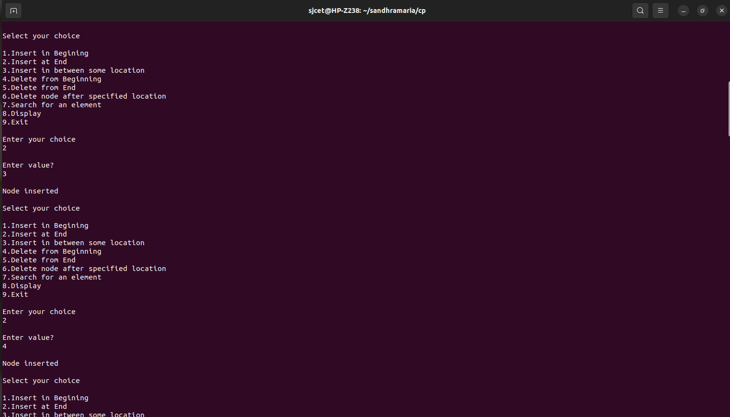

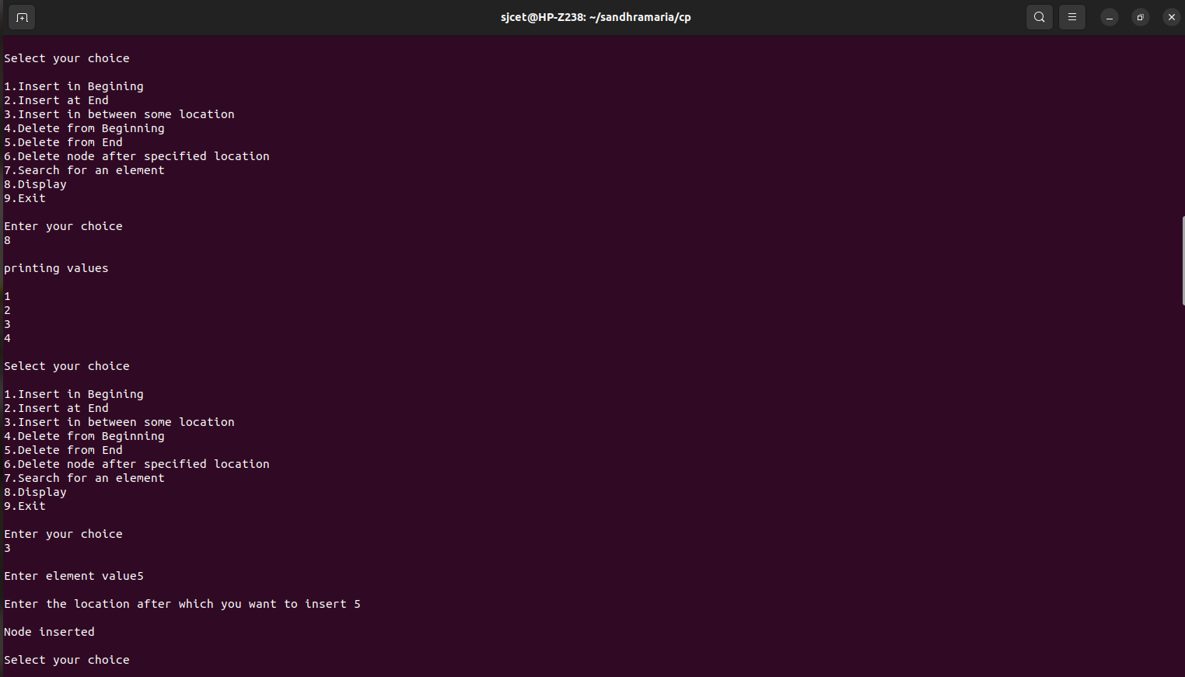

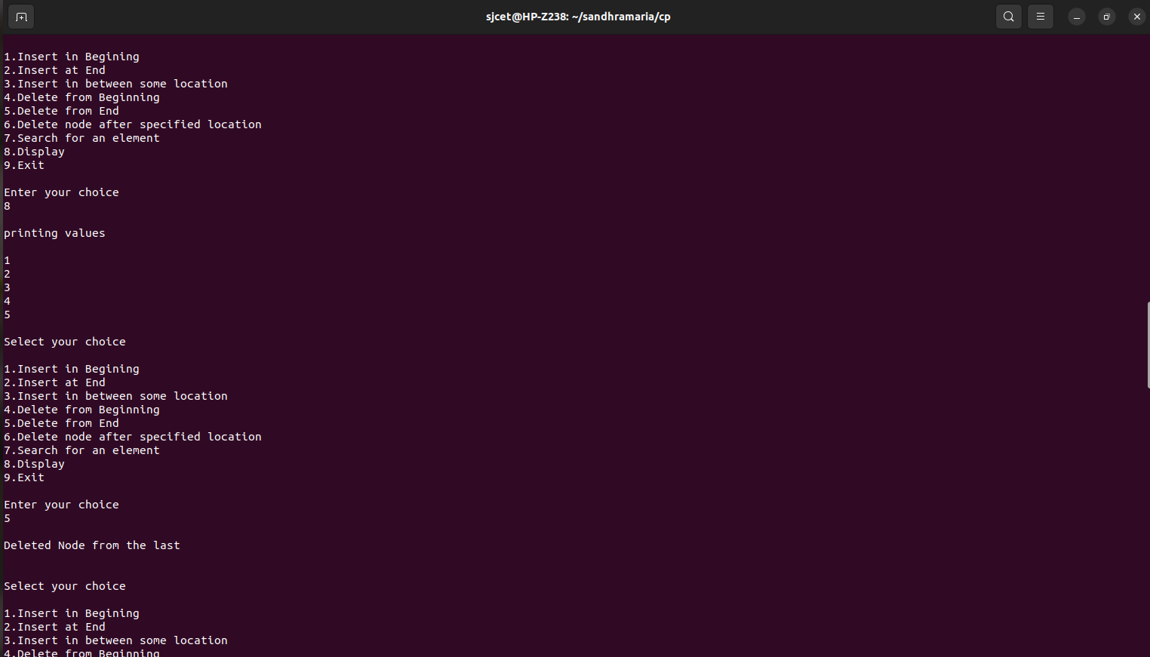

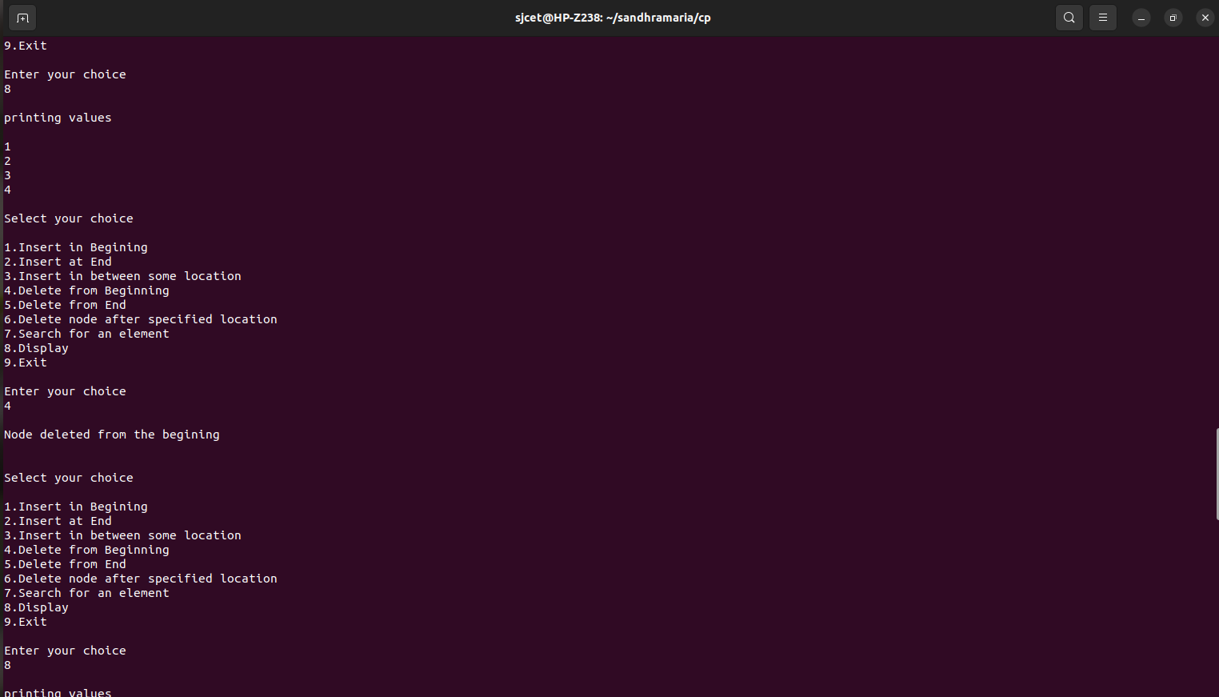

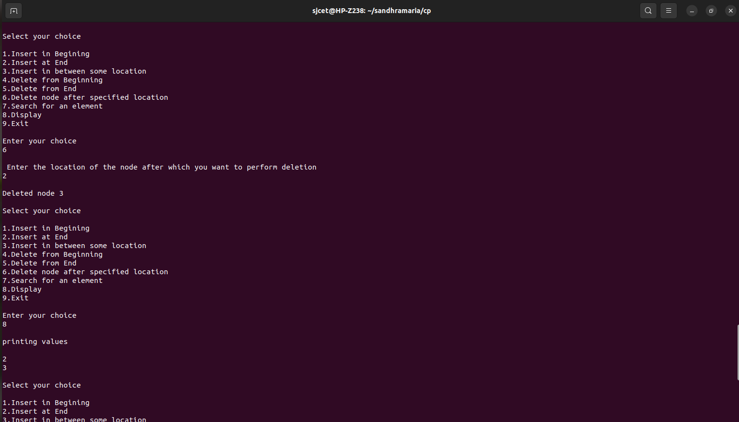

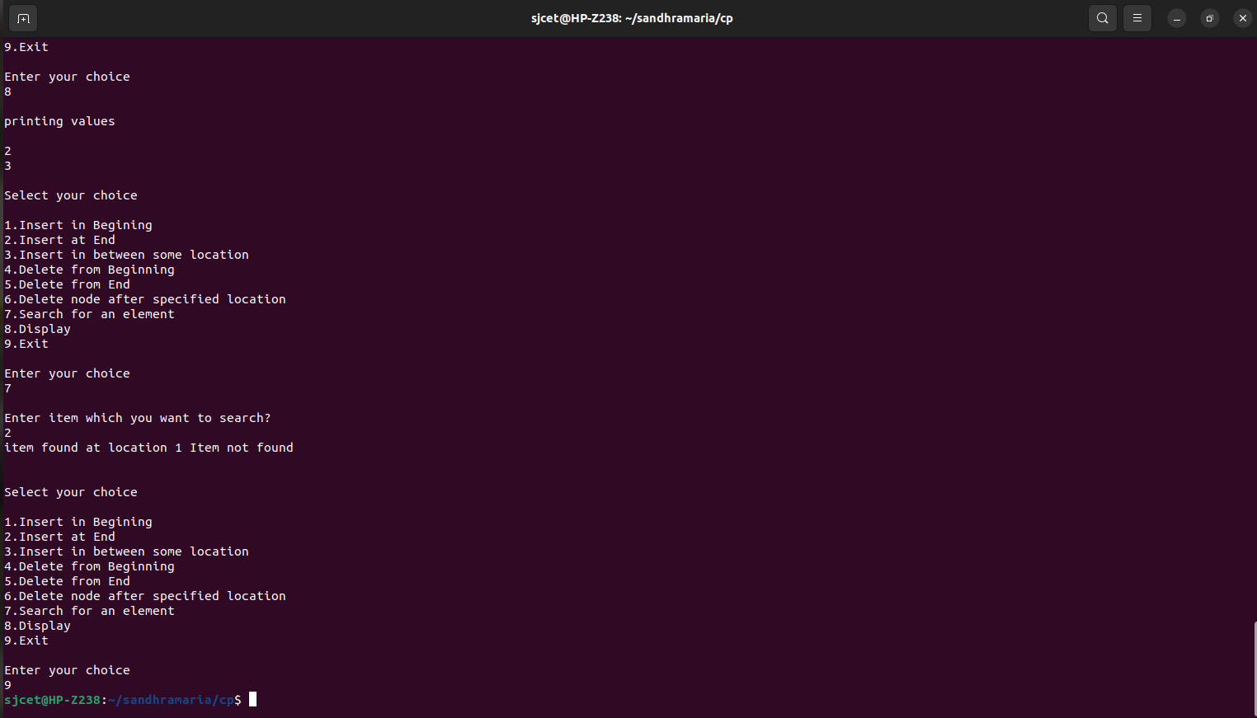

***12. Implementation doubly linked list***

#include<stdio.h>

#include<stdlib.h>

struct node

{

struct node *prev;

struct node *next;

int data;

};

struct node *head;

void insert_begin();

void insert_end();

void insert_middle();

void delete_begin();

void delete_end();

void delete_middle();

void display();

void search();

void main ()

{

int choice =0;

while(choice != 9)

{

printf("\n\nSelect your choice\n");

printf("\n1.Insert in Begining\n2.Insert at End\n3.Insert in between some location\n4.Delete from Beginning\n5.Delete from End\n6.Delete node after specified location\n7.Search for an element\n8.Display\n9.Exit\n");

printf("\nEnter your choice\n");

scanf("\n%d",&choice);

switch(choice)

{

case 1:

insert_begin();

break;

case 2:

insert_end();

break;

case 3:

insert_middle();

break;

case 4:

delete_begin();

break;

case 5:

delete_end();

break;

case 6:

delete_middle();

break;

case 7:

search();

break;

case 8:

display();

break;

case 9:

exit(0);

break;

default:

printf("\nInvalid Choice \n");

printf("NB:Please enter valid choice..");

}

}

}

void insert_begin()

{

struct node *ptr;

int item;

ptr = (struct node *)malloc(sizeof(struct node));

if(ptr == NULL)

{

printf("\nOVERFLOW");

}

else

{

printf("\nEnter Item value");

scanf("%d",&item);

if(head==NULL)

{

ptr->next = NULL;

ptr->prev=NULL;

ptr->data=item;

head=ptr;

}

else

{

ptr->data=item;

ptr->prev=NULL;

ptr->next = head;

head->prev=ptr;

head=ptr;

}

printf("\nNode inserted\n");

}

}

void insert_end()

{

struct node *ptr,*temp;

int item;

ptr = (struct node *) malloc(sizeof(struct node));

if(ptr == NULL)

{

printf("\nOVERFLOW");

}

else

{

printf("\nEnter value");

scanf("%d",&item);

ptr->data=item;

if(head == NULL)

{

ptr->next = NULL;

ptr->prev = NULL;

head = ptr;

}

else

{

temp = head;

while(temp->next!=NULL)

{

temp = temp->next;

}

temp->next = ptr;

ptr ->prev=temp;

ptr->next = NULL;

}

}

printf("\nnode inserted\n");

}

void insert_middle()

{

struct node *ptr,*temp;

int item,loc,i;

ptr = (struct node *)malloc(sizeof(struct node));

if(ptr == NULL)

{

printf("\n OVERFLOW");

}

else

{

temp=head;

printf("Enter the location");

scanf("%d",&loc);

for(i=0;i<loc-2;i++)

{

temp = temp->next;

if(temp == NULL)

{

printf("\n There are less than %d elements", loc);

return;

}

}

printf("Enter value");

scanf("%d",&item);

ptr->data = item;

ptr->next = temp->next;

ptr -> prev = temp;

temp->next = ptr;

temp->next->prev=ptr;

printf("\nnode inserted\n");

}

}

void delete_begin()

{

struct node *ptr;

if(head == NULL)

{

printf("\n UNDERFLOW");

}

else if(head->next == NULL)

{

head = NULL;

free(head);

printf("\nnode deleted\n");

}

else

{

ptr = head;

head = head -> next;

head -> prev = NULL;

free(ptr);

printf("\nnode deleted\n");

}

}

void delete_end()

{

struct node *ptr;

if(head == NULL)

{

printf("\n UNDERFLOW");

}

else if(head->next == NULL)

{

head = NULL;

free(head);

printf("\nNode deleted\n");

}

else

{

ptr = head;

if(ptr->next != NULL)

{

ptr=ptr->next;

}

ptr->prev->next=NULL;

free(ptr);

printf("\nNode deleted\n");

}

}

void delete_middle()

{

struct node *ptr, *temp;

int val;

printf("\n Enter the data after which the node is to be deleted : ");

scanf("%d", &val);

ptr = head;

while(ptr->data!=val)

ptr=ptr->next;

if(ptr->next==NULL)

{

printf("\nCan't delete\n");

}

else if(ptr->next->next==NULL)

{

ptr->next=NULL;

}

else

{

temp = ptr->next;

ptr->next=temp->next;

temp -> next -> prev = ptr;

free(temp);

printf("\nNode deleted\n");

}

}

void display()

{

struct node *ptr;

if(head==NULL)

{

printf("\n UNDERFLOW, Empty list");

}

else

{

printf("\n Values are\n");

ptr = head;

while(ptr!= NULL)

{

printf("%d\n",ptr->data);

ptr=ptr->next;

}

}

}

void search()

{

struct node *ptr;

int item,i=0,flag;

ptr = head;

if(ptr==NULL)

{

printf("\nEmpty List\n");

}

else

{

printf("\nEnter item which you want to search?\n");

scanf("%d",&item);

while (ptr!=NULL)

{

if(ptr->data==item)

{

printf("\nitem found at location %d ",i+1);

flag=0;

break;

}

else

{

flag=1;

}

i++;

ptr=ptr->next;

}

if(flag==1)

{

printf("\nItem not found\n");

}

}

}

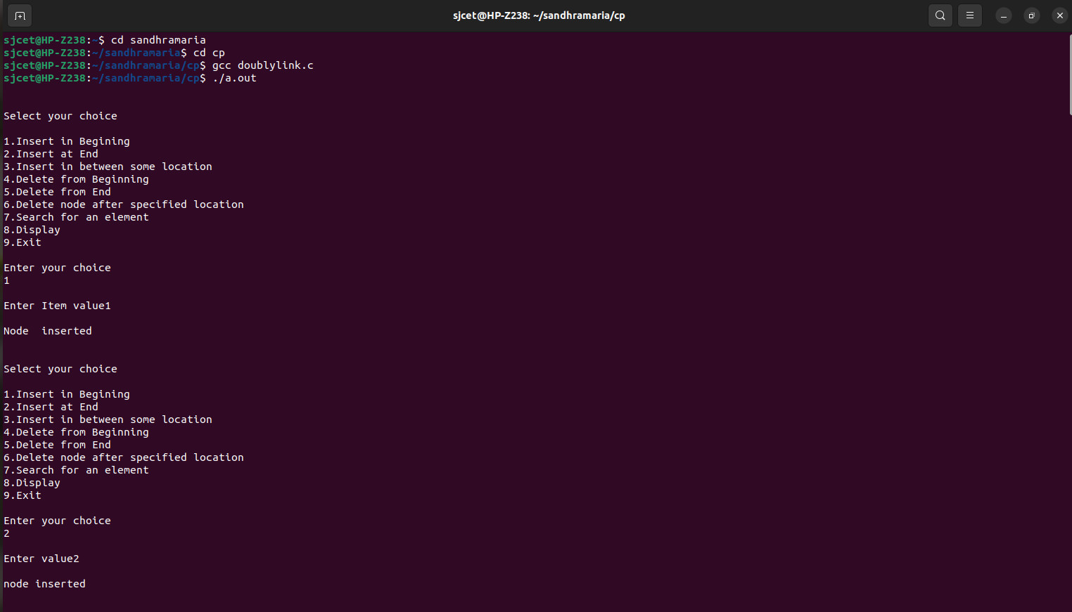

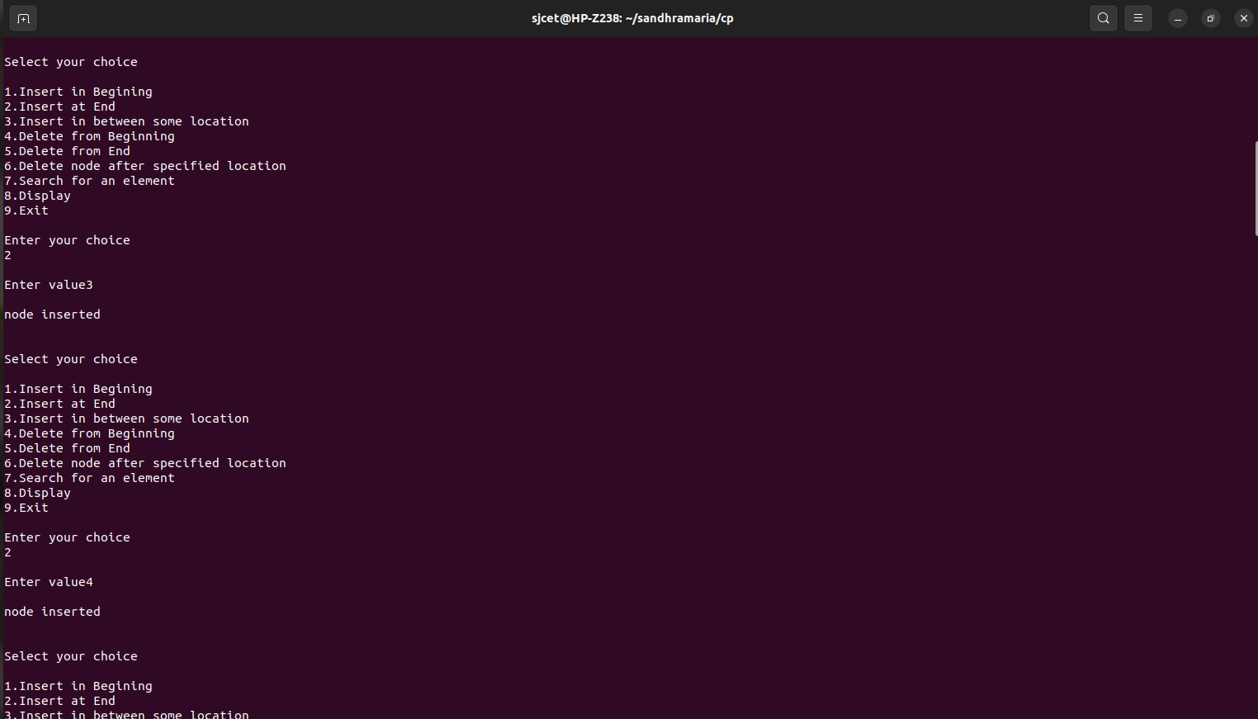

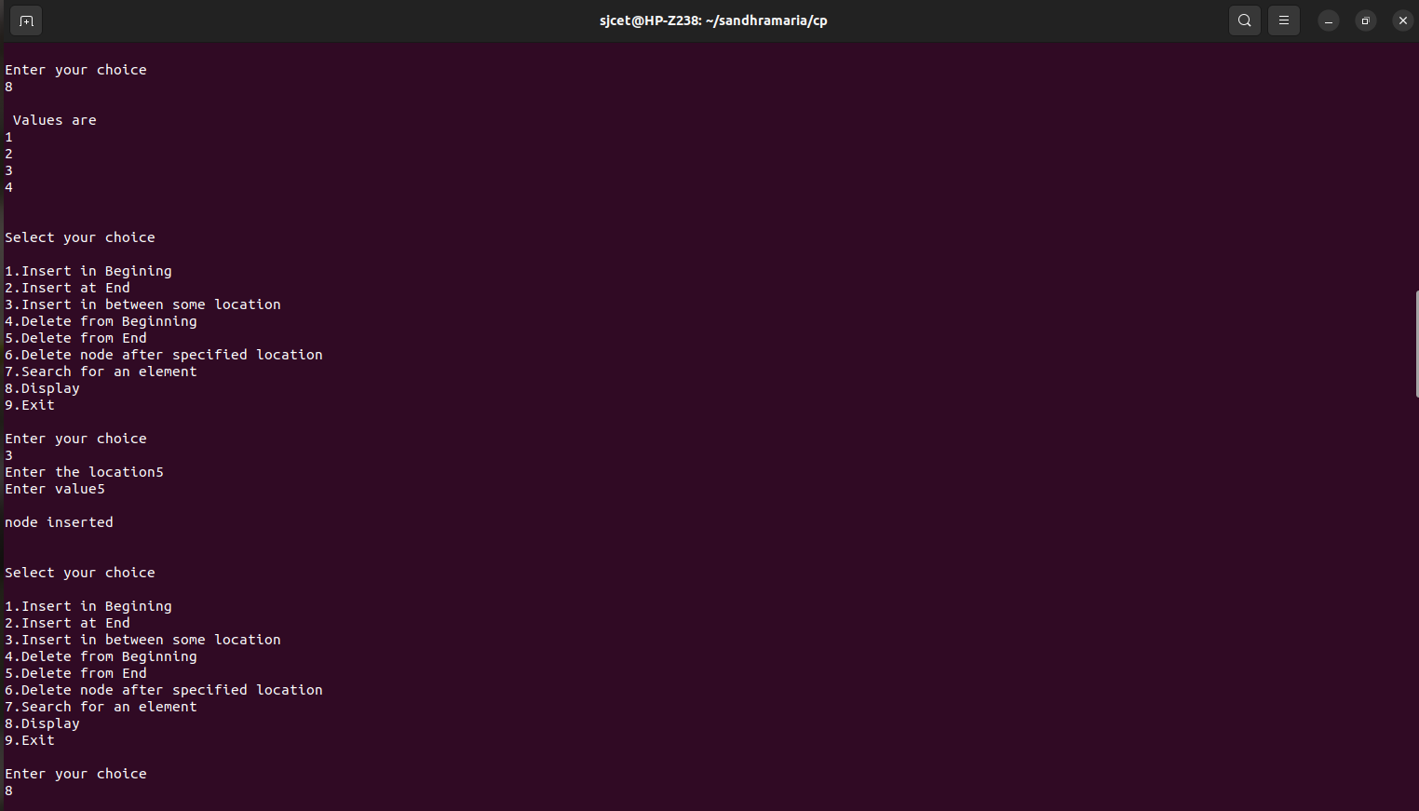



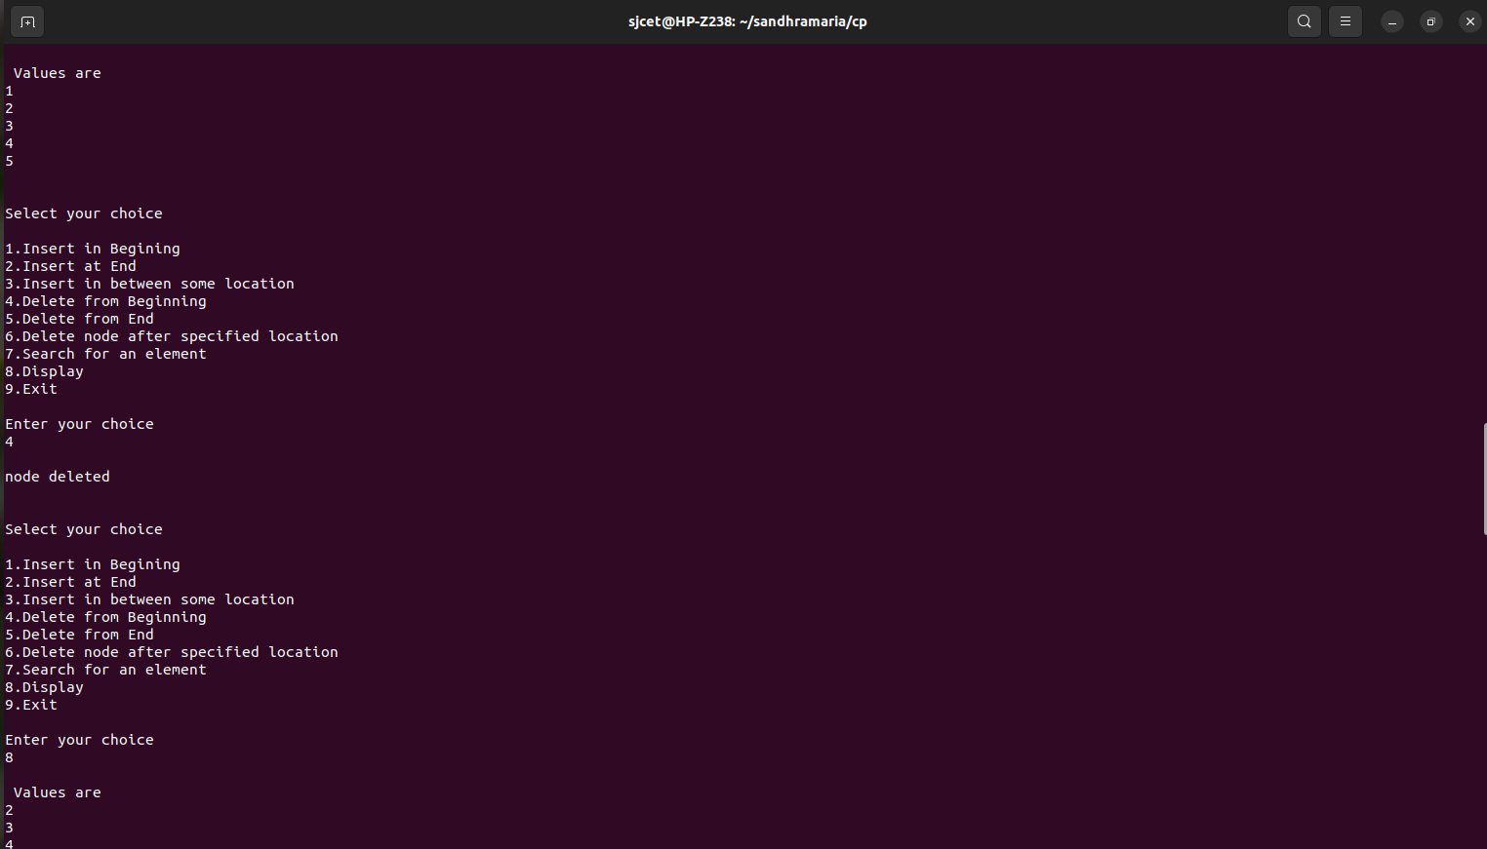

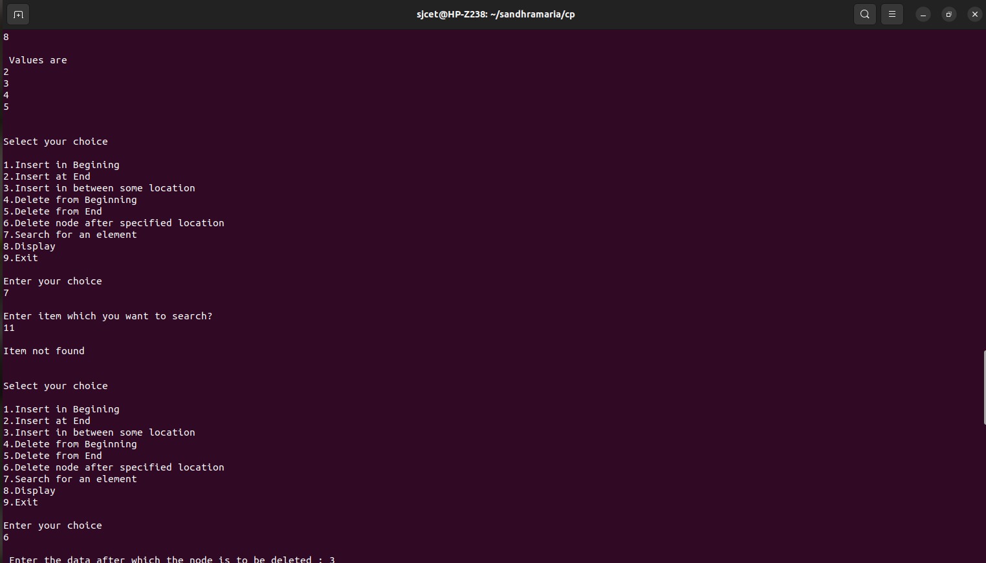

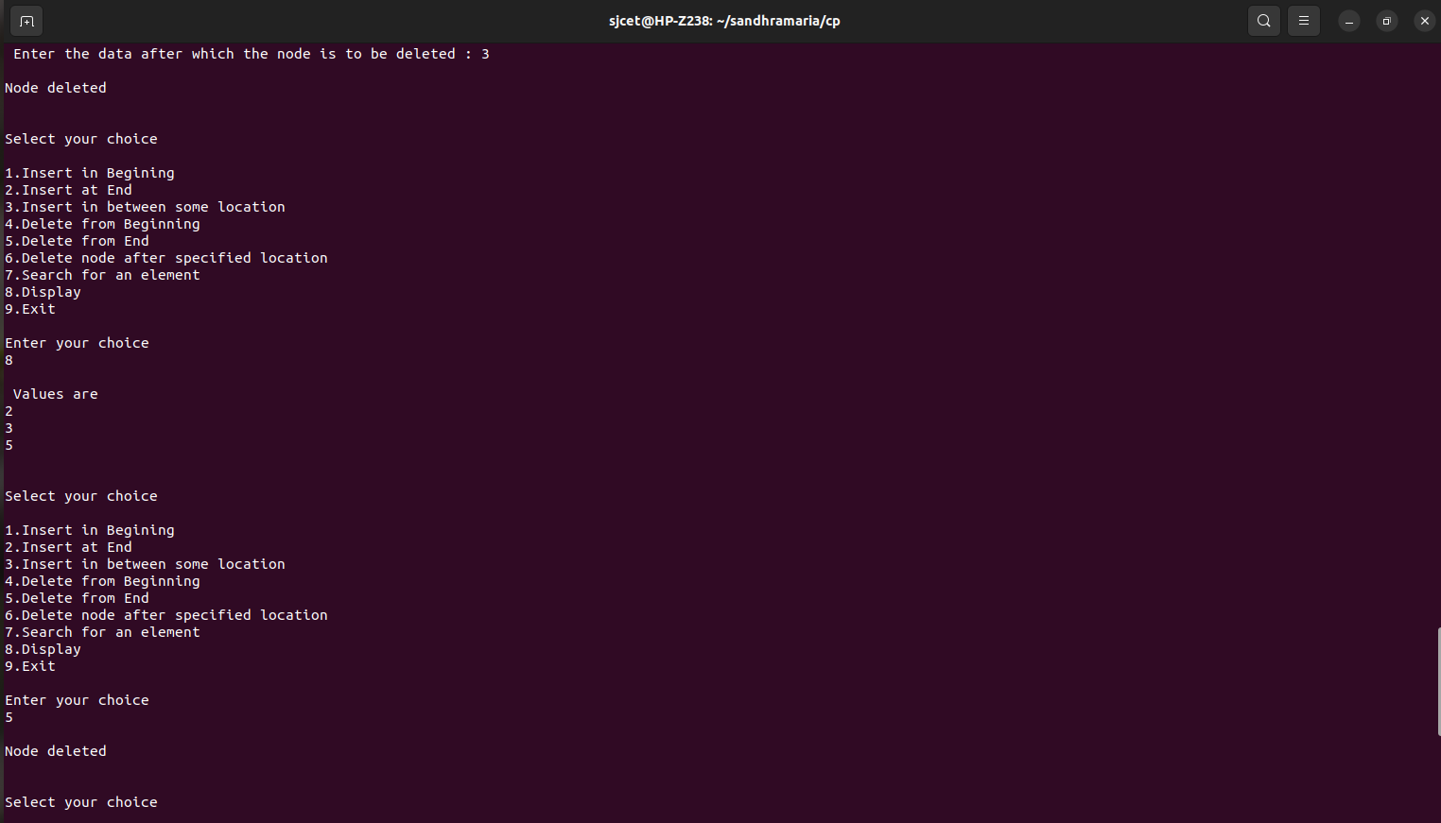

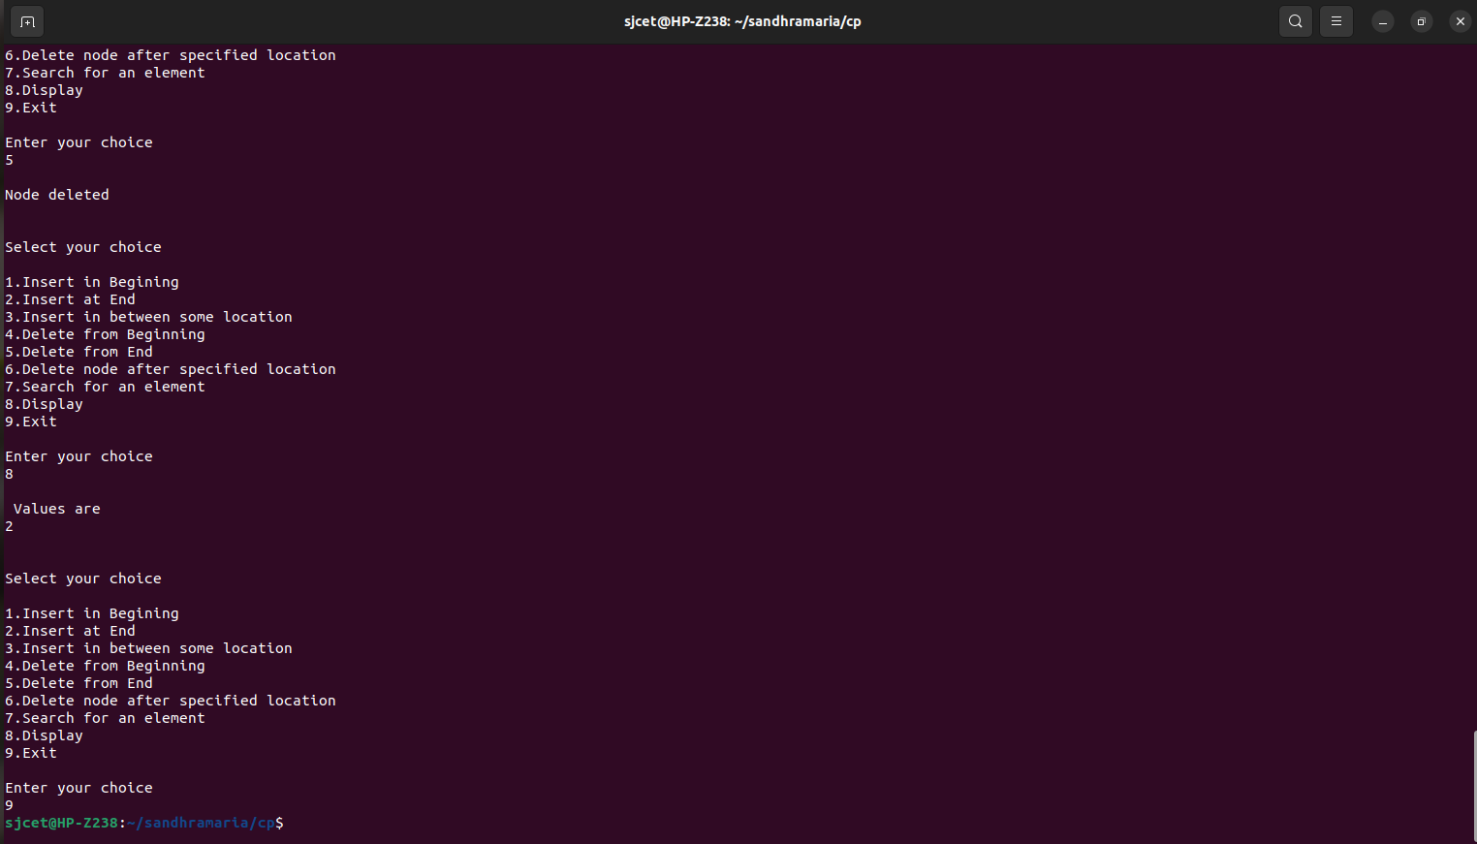

***13.Set operations - Union, Intersection, Difference***

#include<stdio.h>

void main()

{

int a[10],b[10],i,c[10],d[10],e[10],f[10],j,k=0,n1,l,n2,ch,m=0,n=0,p=0;

printf("Enter number of element of set A\n");

scanf("%d",&n1);

printf("Enter the element of set A \n");

for(i=0;i<n1;i++)

scanf("%d",&a[i]);

printf("Enter number of element of set B\n");

scanf("%d",&n2);

printf("Enter the element of set B \n");

for(i=0;i<n2;i++)

scanf("%d",&b[i]);

while(ch!=4)

{

printf("\n\nSelect your choice\n");

printf("\n1.Union of the 2 Sets \n2.Intersection Of The 2 Sets\n3.Differenence between The Sets\n4.Exit\n");

printf("\nEnter your choice\n");

scanf("\n%d",&ch);

switch(ch)

{

case 1:

for(i=0;i<n1;i++)

{

for(j=0;j<k;j++)

{

if(c[j]==a[i])

break;

}

if(j==k)

{

c[k]=a[i];

k++;

}

}

for(i=0;i<n2;i++)

{

for(j=0;j<k;j++)

{

if(c[j]==b[i])

break;

}

if(j==k)

{

c[k]=b[i];

k++;

}

}

printf("Union of set A and B is:-\n");

for(i=0;i<k;i++)

printf("%d ",c[i]);

break;

case 2:

printf("INTERSECTION \n");

for( i=0;i<n1;i++)

{

for(j=0;j<n2;j++)

{

if(a[i]==b[j])

{

d[n]=a[i];

n++;

}

}

}

printf("intersection of set A and set B are:-\n");

for(i=0;i<n;i++)

printf("%d ",d[i]);

break;

case 3:

for( i=0;i<n1;i++)

{

for(j=0;j<n2;j++)

{

if(b[j]==a[i])

break;

}

if(j==n2)

{

for(l=0;l<m;l++)

{

if(e[l]==a[i])

break;

}

if(l==m)

{

e[m]=a[i];

m++;

}

}

}

for( i=0;i<n2;i++)

{

for(j=0;j<n1;j++)

{

if(b[i]==a[j])

break;

}

if(j==n1)

{

for(l=0;l<p;l++)

{

if(d[l]==b[i])

break;

}

if(l==p)

{

d[p]=b[i];

p++;

}

}

}

printf("Difference of A-B is:-\n");

for(i=0;i<m;i++)

{

printf("%d ",e[i]);

}

printf("\n");

printf("Difference of B-A is:-\n");

for(i=0;i<p;i++)

{

printf("%d ",d[i]);

}

}

}

}

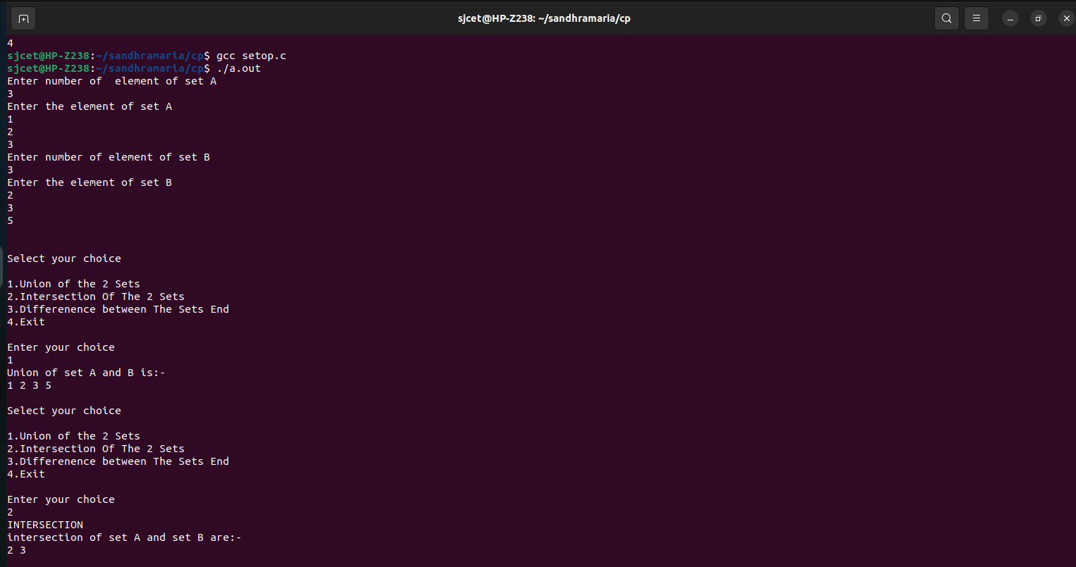

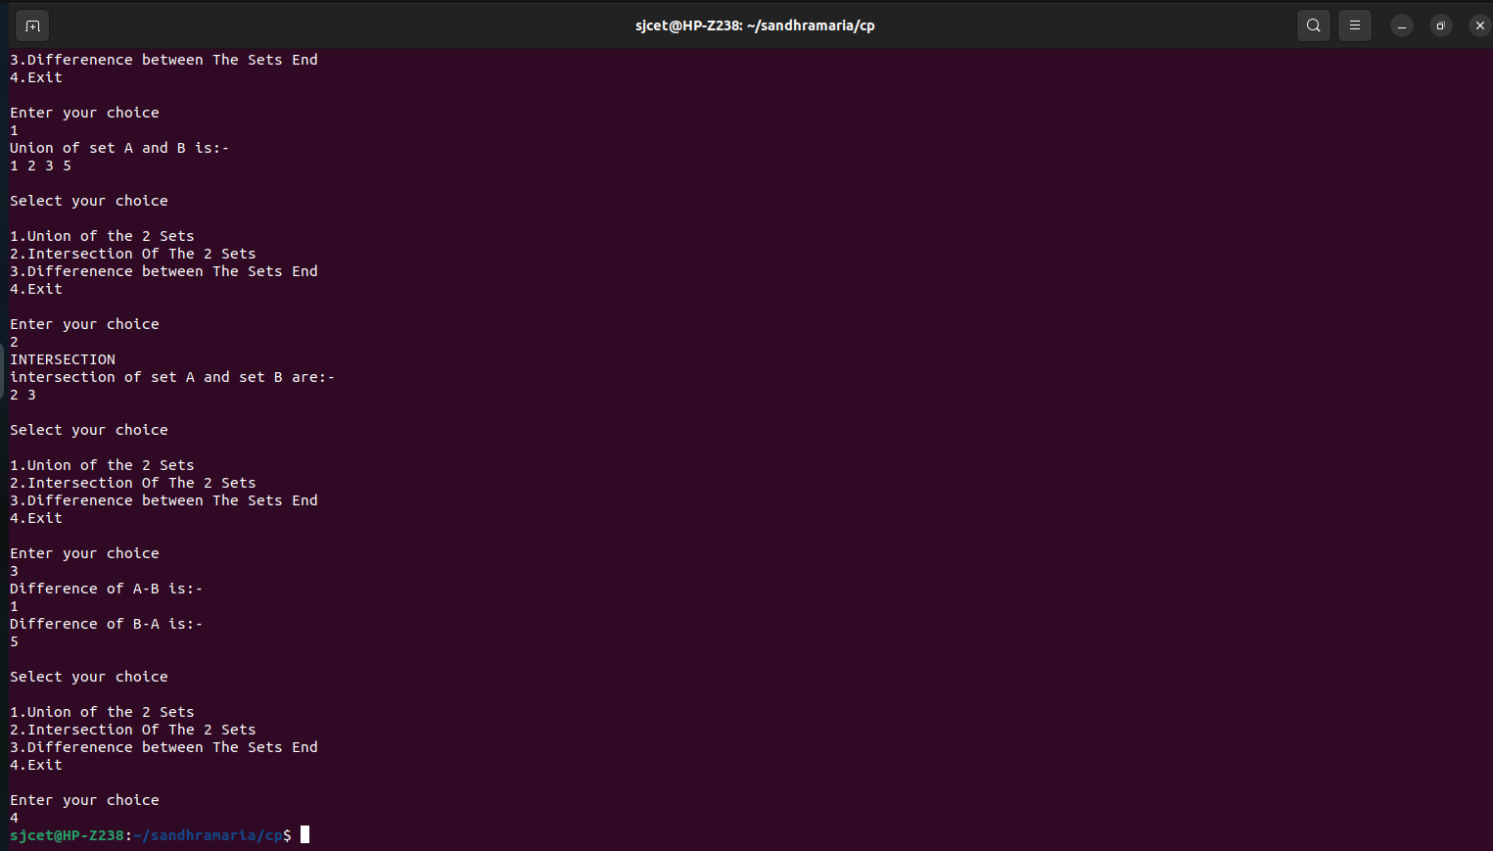

***14. Implementation of binary search tree***

#include <stdio.h>

#include <stdlib.h>

struct node {

int key;

struct node *left, *right;

};

struct node *newNode(int item) {

struct node *temp = (struct node *)malloc(sizeof(struct node));

temp->key = item;

temp->left = temp->right = NULL;

return temp;

}

void inorder(struct node *root) {

if (root != NULL) {

inorder(root->left);

printf("%d ->", root->key);

inorder(root->right);

}

}

struct node *insert(struct node *node, int key) {

if (node == NULL) return newNode(key);

if (key < node->key)

node->left = insert(node->left, key);

else

node->right = insert(node->right, key);

return node;

}

struct node *minValueNode(struct node *node) {

struct node *current = node;

while (current && current->left != NULL)

current = current->left;

return current;

}

struct node *deleteNode(struct node *root, int key) {

if (root == NULL) return root;

if (key < root->key)

root->left = deleteNode(root->left, key);

else if (key > root->key)

root->right = deleteNode(root->right, key);

else {

if (root->left == NULL) {

struct node *temp = root->right;

free(root);

return temp;

} else if (root->right == NULL) {

struct node *temp = root->left;

free(root);

return temp;

}

struct node *temp = minValueNode(root->right);

root->key = temp->key;

root->right = deleteNode(root->right, temp->key);

}

return root;

}

void main()

{

struct node *root = NULL;

int choice, n;

while(1){

printf(" \n1.Insertion");

printf("\n 2.Deleteion");

printf("\n 3.Traversal");

printf("\n 4.Exit");

printf("\nEnter your choice:\n");

scanf("%d",&choice);

switch(choice)

{

case 1: printf("Enter the element to be Inserted:");

scanf("%d",&n);

root = insert(root, n);

break;

case 2: printf("Enter the element to be Deleted:");

scanf("%d",&n);

root = deleteNode(root, n);

break;

case 3: printf("Inorder traversal:");

inorder(root);

break;

case 4:

exit(0);

break;

default:

printf("n Wrong Choice:n");

break;

}

}

}

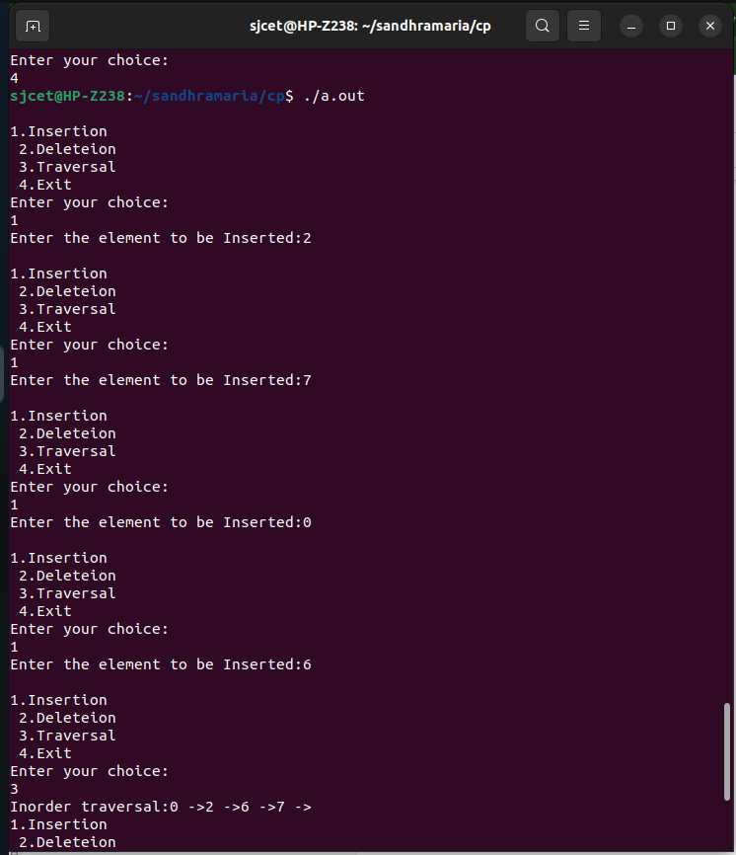

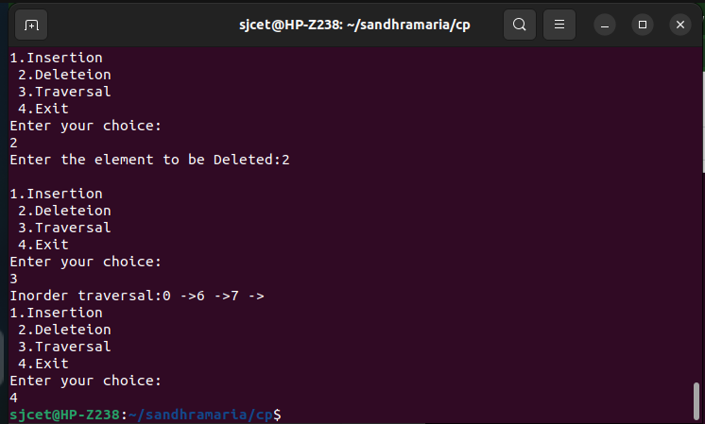

***15.Implementation of B-tree***

#include <stdio.h>

#include <stdlib.h>

#define MAX 3

#define MIN 2

struct BTreeNode {

int val[MAX + 1], count;

struct BTreeNode *link[MAX + 1];

};

struct BTreeNode *root;

struct BTreeNode *createNode(int val, struct BTreeNode *child)

{

struct BTreeNode *newNode;

newNode = (struct BTreeNode *)malloc(sizeof(struct BTreeNode));

newNode->val[1] = val;

newNode->count = 1;

newNode->link[0] = root;

newNode->link[1] = child;

return newNode;

}

void insertNode(int val, int pos, struct BTreeNode *node,

struct BTreeNode *child) {

int j = node->count;

while (j > pos) {

node->val[j + 1] = node->val[j];

node->link[j + 1] = node->link[j];

j--;

}

node->val[j + 1] = val;

node->link[j + 1] = child;

node->count++;

}

void splitNode(int val, int *pval, int pos, struct BTreeNode *node,

struct BTreeNode *child, struct BTreeNode **newNode) {

int median, j;

if (pos > MIN)

median = MIN + 1;

else

median = MIN;

*newNode = (struct BTreeNode *)malloc(sizeof(struct BTreeNode));

j = median + 1;

while (j <= MAX) {

(*newNode)->val[j - median] = node->val[j];

(*newNode)->link[j - median] = node->link[j];

j++;

}

node->count = median;

(*newNode)->count = MAX - median;

if (pos <= MIN) {

insertNode(val, pos, node, child);

} else {

insertNode(val, pos - median, *newNode, child);

}

*pval = node->val[node->count];

(*newNode)->link[0] = node->link[node->count];

node->count--;

}

int setValue(int val, int *pval,

struct BTreeNode *node, struct BTreeNode **child) {

int pos;

if (!node) {

*pval = val;

*child = NULL;

return 1;

}

if (val < node->val[1]) {

pos = 0;

} else {

for (pos = node->count;

(val < node->val[pos] && pos > 1); pos--)

;

if (val == node->val[pos]) {

printf("Duplicates are not permitted\n");

return 0;

}

}

if (setValue(val, pval, node->link[pos], child)) {

if (node->count < MAX) {

insertNode(*pval, pos, node, *child);

} else {

splitNode(*pval, pval, pos, node, *child, child);

return 1;

}

}

return 0;

}

void insert(int val) {

int flag, i;

struct BTreeNode *child;

flag = setValue(val, &i, root, &child);

if (flag)

root = createNode(i, child);

}

void search(int val, int *pos, struct BTreeNode *myNode) {

if (!myNode) {

return;

}

if (val < myNode->val[1]) {

*pos = 0;

} else {

for (*pos = myNode->count;

(val < myNode->val[*pos] && *pos > 1); (*pos)--)

;

if (val == myNode->val[*pos]) {

printf("%d is found", val);

return;

}

}

search(val, pos, myNode->link[*pos]);

return;

}

void traversal(struct BTreeNode *myNode) {

int i;

if (myNode) {

for (i = 0; i < myNode->count; i++) {

traversal(myNode->link[i]);

printf("%d ", myNode->val[i + 1]);

}

traversal(myNode->link[i]);

}

}

int main() {

int val, ch;

insert(8);

insert(9);

insert(10);

insert(11);

insert(15);

insert(16);

insert(17);

insert(18);

insert(20);

insert(23);

traversal(root);

printf("\n");

search(11, &ch, root);

}

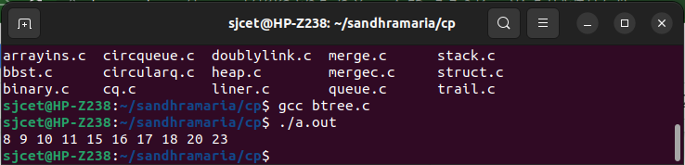

***16. Implementation of disjoint set***

#include<stdio.h>

struct disjointset

{

int parent[20];

int rank[10];

int n;

};

struct disjointset dis;

void makeset()

{

int i;

for(i=0;i<dis.n;i++)

{

dis.parent[i]=i;

dis.rank[i]=0;

}

}

void displayset()

{

int i;

printf("\n Parent array\n");

for(i=0;i<dis.n;i++)

{

printf("%d",dis.parent[i]);

}

printf("\n rank of array\n");

for(i=0;i<dis.n;i++)

printf("%d",dis.rank[i]);

printf("\n");

}

int find(int x)

{

if(dis.parent[x]!=x)

dis.parent[x]=find(dis.parent[x]);

return dis.parent[x];

}

void Union(int x,int y)

{

int xset=find(x),yset=find(y);

if(xset==yset)

return;

if(dis.rank[xset]<dis.rank[yset])

{dis.parent[xset]=yset;

dis.rank[xset]=-1;

}

else if(dis.rank[xset]>dis.rank[yset])

{

dis.parent[yset]=xset;

dis.rank[yset]=-1;

}

else

{

dis.parent[yset]=xset;

dis.rank[xset]=dis.rank[xset]+1;

dis.rank[yset]=-1;

}

}

int main()

{

int x,y,n;

printf("\n Enter number of elements: ");

scanf("%d",&dis.n);

makeset();

int ch,w;

printf("\n1.UNION\n2.FIND\n3.DISPLAY");

do{

printf("\nEnter choice: ");

scanf("%d",&ch);

switch(ch)

{

case 1:

printf("\n Enter elements to perform union: ");

scanf("%d%d",&x,&y);

Union(x,y);

break;

case 2:

printf("\nEnter the elements to check if connected components:");

scanf("%d%d",&x,&y);

if(find(x)==find(y))

printf("\n connected components");

else

printf("\n no connected components");

break;

case 3:

displayset();

break;

case 4:

printf("EXIT");

break;

}

}while(ch!=4);

return 0;

}

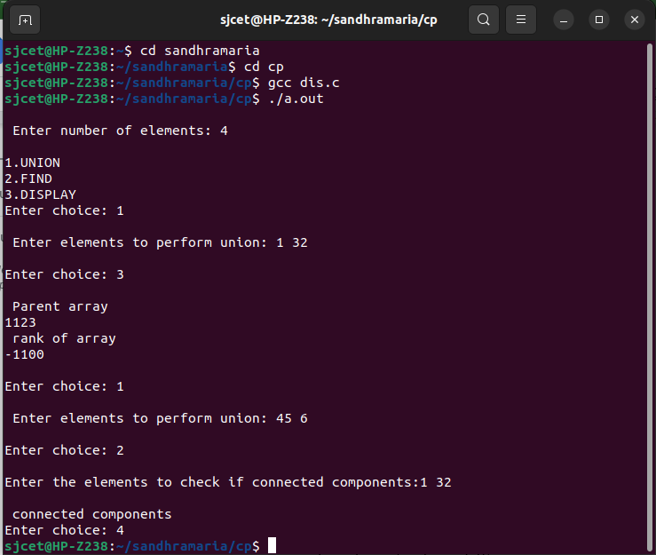

***17. Implementation of Balanced Binary search Tree***

#include <stdio.h>

#include <stdlib.h>

#define bool int

struct node {

int item;

struct node *left;

struct node *right;

};

struct node *newNode(int item)

{

struct node *node = (struct node *)malloc(sizeof(struct node));

node->item = item;

node->left = NULL;

node->right = NULL;

return (node);

}

bool checkHeightBalance(struct node *root, int *height) {

int leftHeight = 0, rightHeight = 0;

int l = 0, r = 0;

if (root == NULL)

{

*height = 0;

return 1;

}

l = checkHeightBalance(root->left, &leftHeight);

r = checkHeightBalance(root->right, &rightHeight);

*height = (leftHeight > rightHeight ? leftHeight : rightHeight) + 1;

if ((leftHeight - rightHeight >= 2) || (rightHeight - leftHeight >= 2))

return 0;

else

return l && r;

}

int main()

{

int height = 0;

struct node *root = newNode(1);

root->left = newNode(2);

root->right = newNode(3);

root->left->left = newNode(4);

root->left->right = newNode(5);

root->left->right->right = newNode(6);

if (checkHeightBalance(root, &height))

printf("The tree is balanced");

else

printf("The tree is not balanced");

}

￼￼￼

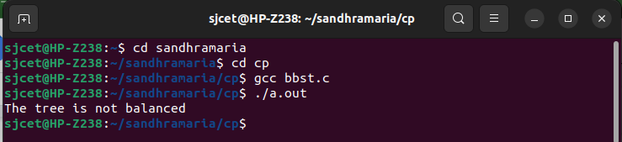

***18.Max-Heap implementation***

#include <stdio.h>

int size = 0;

void swap(int *a, int *b)

{

int temp = *b;

*b = *a;

*a = temp;

}

void heapify(int array[], int size, int i)

{

if (size == 1)

{

printf("Single element in the heap");

}

else

{

int largest = i;

int l = 2 * i + 1;

int r = 2 * i + 2;

if (l < size && array[l] > array[largest])

largest = l;

if (r < size && array[r] > array[largest])

largest = r;

if (largest != i)

{

swap(&array[i], &array[largest]);

heapify(array, size, largest);

}

}

}

void insert(int array[], int newNum)

{

if (size == 0)

{

array[0] = newNum;

size += 1;

}

else

{

array[size] = newNum;

size += 1;

for (int i = size / 2 - 1; i >= 0; i--)

{

heapify(array, size, i);

}

}

}

void deleteRoot(int array[], int num)

{

int i;

for (i = 0; i < size; i++)

{

if (num == array[i])

break;

}

swap(&array[i], &array[size - 1]);

size -= 1;

for (int i = size / 2 - 1; i >= 0; i--)

{

heapify(array, size, i);

}

}

void printArray(int array[], int size)

{

for (int i = 0; i < size; ++i)

printf("%d ", array[i]);

printf("\n");

}

int main()

{

int array[10];

insert(array, 3);

insert(array, 4);

insert(array, 9);

insert(array, 5);

insert(array, 2);

printf("Max-Heap array: ");

printArray(array, size);

deleteRoot(array, 9);

printf("After deleting an element: ");

printArray(array, size);

}

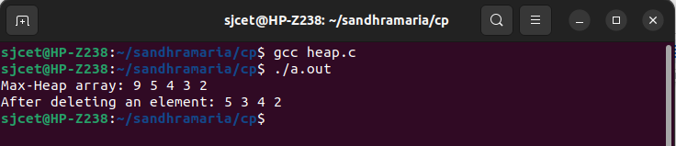

***19. Red-Black tree implementation***

#include <stdio.h>

#include <stdlib.h>

enum nodeColor {

RED,BLACK

};

struct rbNode {

int data, color;

struct rbNode *link[2];

};

struct rbNode *root = NULL;

struct rbNode *createNode(int data) {

struct rbNode *newnode;

newnode = (struct rbNode *)malloc(sizeof(struct rbNode));

newnode->data = data;

newnode->color = RED;

newnode->link[0] = newnode->link[1] = NULL;

return newnode;

}

void insertion(int data) {

struct rbNode *stack[98], *ptr, *newnode, *xPtr, *yPtr;

int dir[98], ht = 0, index;

ptr = root;

if (!root) {

root = createNode(data);

return;

}

stack[ht] = root;

dir[ht++] = 0;

while (ptr != NULL) {

if (ptr->data == data) {

printf("Duplicates Not Allowed!!\n");

return;

}

index = (data - ptr->data) > 0 ? 1 : 0;

stack[ht] = ptr;

ptr = ptr->link[index];

dir[ht++] = index;

}

stack[ht - 1]->link[index] = newnode = createNode(data);

while ((ht >= 3) && (stack[ht - 1]->color == RED)) {

if (dir[ht - 2] == 0) {

yPtr = stack[ht - 2]->link[1];

if (yPtr != NULL && yPtr->color == RED) {

stack[ht - 2]->color = RED;

stack[ht - 1]->color = yPtr->color = BLACK;

ht = ht - 2;

} else {

if (dir[ht - 1] == 0) {

yPtr = stack[ht - 1];

} else {

xPtr = stack[ht - 1];

yPtr = xPtr->link[1];

xPtr->link[1] = yPtr->link[0];

yPtr->link[0] = xPtr;

stack[ht - 2]->link[0] = yPtr;

}

xPtr = stack[ht - 2];

xPtr->color = RED;

yPtr->color = BLACK;

xPtr->link[0] = yPtr->link[1];

yPtr->link[1] = xPtr;

if (xPtr == root) {

root = yPtr;

} else {

stack[ht - 3]->link[dir[ht - 3]] = yPtr;

}

break;

}

} else {

yPtr = stack[ht - 2]->link[0];

if ((yPtr != NULL) && (yPtr->color == RED)) {

stack[ht - 2]->color = RED;

stack[ht - 1]->color = yPtr->color = BLACK;

ht = ht - 2;

} else {

if (dir[ht - 1] == 1) {

yPtr = stack[ht - 1];

} else {

xPtr = stack[ht - 1];

yPtr = xPtr->link[0];

xPtr->link[0] = yPtr->link[1];

yPtr->link[1] = xPtr;

stack[ht - 2]->link[1] = yPtr;

}

xPtr = stack[ht - 2];

yPtr->color = BLACK;

xPtr->color = RED;

xPtr->link[1] = yPtr->link[0];

yPtr->link[0] = xPtr;

if (xPtr == root) {

root = yPtr;

} else {

stack[ht - 3]->link[dir[ht - 3]] = yPtr;

}

break;

}

}

}

root->color = BLACK;

}

void deletion(int data) {

struct rbNode *stack[98], *ptr, *xPtr, *yPtr;

struct rbNode *pPtr, *qPtr, *rPtr;

int dir[98], ht = 0, diff, i;

enum nodeColor color;

if (!root) {

printf("Tree not available\n");

return;

}

ptr = root;

while (ptr != NULL) {

if ((data - ptr->data) == 0)

break;

diff = (data - ptr->data) > 0 ? 1 : 0;

stack[ht] = ptr;

dir[ht++] = diff;

ptr = ptr->link[diff];

}

if (ptr->link[1] == NULL) {

if ((ptr == root) && (ptr->link[0] == NULL)) {

free(ptr);

root = NULL;

} else if (ptr == root) {

root = ptr->link[0];

free(ptr);

} else {

stack[ht - 1]->link[dir[ht - 1]] = ptr->link[0];

}

} else {

xPtr = ptr->link[1];

if (xPtr->link[0] == NULL) {

xPtr->link[0] = ptr->link[0];

color = xPtr->color;

xPtr->color = ptr->color;

ptr->color = color;

if (ptr == root) {

root = xPtr;

} else {

stack[ht - 1]->link[dir[ht - 1]] = xPtr;

}

dir[ht] = 1;

stack[ht++] = xPtr;

} else {

i = ht++;

while (1) {

dir[ht] = 0;

stack[ht++] = xPtr;

yPtr = xPtr->link[0];

if (!yPtr->link[0])

break;

xPtr = yPtr;

}

dir[i] = 1;

stack[i] = yPtr;

if (i > 0)

stack[i - 1]->link[dir[i - 1]] = yPtr;

yPtr->link[0] = ptr->link[0];

xPtr->link[0] = yPtr->link[1];

yPtr->link[1] = ptr->link[1];

if (ptr == root) {

root = yPtr;

}

color = yPtr->color;

yPtr->color = ptr->color;

ptr->color = color;

}

}

if (ht < 1)

return;

if (ptr->color == BLACK) {

while (1) {

pPtr = stack[ht - 1]->link[dir[ht - 1]];

if (pPtr && pPtr->color == RED) {

pPtr->color = BLACK;

break;

}

if (ht < 2)

break;

if (dir[ht - 2] == 0) {

rPtr = stack[ht - 1]->link[1];

if (!rPtr)

break;

if (rPtr->color == RED) {

stack[ht - 1]->color = RED;

rPtr->color = BLACK;

stack[ht - 1]->link[1] = rPtr->link[0];

rPtr->link[0] = stack[ht - 1];

if (stack[ht - 1] == root) {

root = rPtr;

} else {

stack[ht - 2]->link[dir[ht - 2]] = rPtr;

}

dir[ht] = 0;

stack[ht] = stack[ht - 1];

stack[ht - 1] = rPtr;

ht++;

rPtr = stack[ht - 1]->link[1];

}

if ((!rPtr->link[0] || rPtr->link[0]->color == BLACK) &&

(!rPtr->link[1] || rPtr->link[1]->color == BLACK)) {

rPtr->color = RED;

} else {

if (!rPtr->link[1] || rPtr->link[1]->color == BLACK) {

qPtr = rPtr->link[0];

rPtr->color = RED;

qPtr->color = BLACK;

rPtr->link[0] = qPtr->link[1];

qPtr->link[1] = rPtr;

rPtr = stack[ht - 1]->link[1] = qPtr;

}

rPtr->color = stack[ht - 1]->color;

stack[ht - 1]->color = BLACK;

rPtr->link[1]->color = BLACK;

stack[ht - 1]->link[1] = rPtr->link[0];

rPtr->link[0] = stack[ht - 1];

if (stack[ht - 1] == root) {

root = rPtr;

} else {

stack[ht - 2]->link[dir[ht - 2]] = rPtr;

}

break;

}

} else {

rPtr = stack[ht - 1]->link[0];

if (!rPtr)

break;

if (rPtr->color == RED) {

stack[ht - 1]->color = RED;

rPtr->color = BLACK;

stack[ht - 1]->link[0] = rPtr->link[1];

rPtr->link[1] = stack[ht - 1];

if (stack[ht - 1] == root) {

root = rPtr;

} else {

stack[ht - 2]->link[dir[ht - 2]] = rPtr;

}

dir[ht] = 1;

stack[ht] = stack[ht - 1];

stack[ht - 1] = rPtr;

ht++;

rPtr = stack[ht - 1]->link[0];

}

if ((!rPtr->link[0] || rPtr->link[0]->color == BLACK) &&

(!rPtr->link[1] || rPtr->link[1]->color == BLACK)) {

rPtr->color = RED;

} else {

if (!rPtr->link[0] || rPtr->link[0]->color == BLACK) {

qPtr = rPtr->link[1];

rPtr->color = RED;

qPtr->color = BLACK;

rPtr->link[1] = qPtr->link[0];

qPtr->link[0] = rPtr;

rPtr = stack[ht - 1]->link[0] = qPtr;

}

rPtr->color = stack[ht - 1]->color;

stack[ht - 1]->color = BLACK;

rPtr->link[0]->color = BLACK;

stack[ht - 1]->link[0] = rPtr->link[1];

rPtr->link[1] = stack[ht - 1];

if (stack[ht - 1] == root) {

root = rPtr;

} else {

stack[ht - 2]->link[dir[ht - 2]] = rPtr;

}

break;

}

}

ht--;

}

}

}

void inorderTraversal(struct rbNode *node) {

if (node) {

inorderTraversal(node->link[0]);

printf("%d ", node->data);

inorderTraversal(node->link[1]);

}

return;

}

int main() {

int ch, data;

while (1) {

printf("1. Insertion\t2. Deletion\n");

printf("3. Traverse\t4. Exit");

printf("\nEnter your choice:");

scanf("%d", &ch);

switch (ch) {

case 1:

printf("Enter the element to insert:");

scanf("%d", &data);

insertion(data);

break;

case 2:

printf("Enter the element to delete:");

scanf("%d", &data);

deletion(data);

break;

case 3:

inorderTraversal(root);

printf("\n");

break;

case 4:

exit(0);

default:

printf("Not available\n");

break;

}

printf("\n");

}

return 0;

}

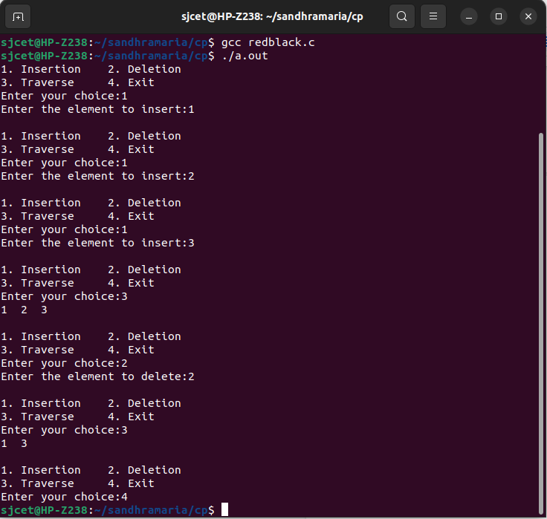0

***20. Implementation of binomial heap***

#include<stdio.h>

#include<malloc.h>

struct node {

int n;

int degree;

struct node* parent;

struct node* child;

struct node* sibling;

};

struct node* MAKE_bin_HEAP();

int bin_LINK(struct node*, struct node*);

struct node* CREATE_NODE(int);

struct node* bin_HEAP_UNION(struct node*, struct node*);

struct node* bin_HEAP_INSERT(struct node*, struct node*);

struct node* bin_HEAP_MERGE(struct node*, struct node*);

struct node* bin_HEAP_EXTRACT_MIN(struct node*);

int REVERT_LIST(struct node*);

int DISPLAY(struct node*);

struct node* FIND_NODE(struct node*, int);

int bin_HEAP_DECREASE_KEY(struct node*, int, int);

int bin_HEAP_DELETE(struct node*, int);

int count = 1;

struct node* MAKE_bin_HEAP() {

struct node* np;

np = NULL;

return np;

}

struct node * H = NULL;

struct node *Hr = NULL;

int bin_LINK(struct node* y, struct node* z) {

y->parent = z;

y->sibling = z->child;

z->child = y;

z->degree = z->degree + 1;

}

struct node* CREATE_NODE(int k) {

struct node* p;//new node;

p = (struct node*) malloc(sizeof(struct node));

p->n = k;

return p;

}

struct node* bin_HEAP_UNION(struct node* H1, struct node* H2) {

struct node* prev_x;

struct node* next_x;

struct node* x;

struct node* H = MAKE_bin_HEAP();

H = bin_HEAP_MERGE(H1, H2);

if (H == NULL)

return H;

prev_x = NULL;

x = H;

next_x = x->sibling;

while (next_x != NULL) {

if ((x->degree != next_x->degree) || ((next_x->sibling != NULL)

&& (next_x->sibling)->degree == x->degree)) {

prev_x = x;

x = next_x;

} else {

if (x->n <= next_x->n) {

x->sibling = next_x->sibling;

bin_LINK(next_x, x);

} else {

if (prev_x == NULL)

H = next_x;

else

prev_x->sibling = next_x;

bin_LINK(x, next_x);

x = next_x;

}

}

next_x = x->sibling;

}

return H;

}

struct node* bin_HEAP_INSERT(struct node* H, struct node* x) {

struct node* H1 = MAKE_bin_HEAP();

x->parent = NULL;

x->child = NULL;

x->sibling = NULL;

x->degree = 0;

H1 = x;

H = bin_HEAP_UNION(H, H1);

return H;

}

struct node* bin_HEAP_MERGE(struct node* H1, struct node* H2) {

struct node* H = MAKE_bin_HEAP();

struct node* y;

struct node* z;

struct node* a;

struct node* b;

y = H1;

z = H2;

if (y != NULL) {

if (z != NULL && y->degree <= z->degree)

H = y;

else if (z != NULL && y->degree > z->degree)

/* need some modifications here;the first and the else conditions can be merged together!!!! */

H = z;

else

H = y;

} else

H = z;

while (y != NULL && z != NULL) {

if (y->degree < z->degree) {

y = y->sibling;

} else if (y->degree == z->degree) {

a = y->sibling;

y->sibling = z;

y = a;

} else {

b = z->sibling;

z->sibling = y;

z = b;

}

}

return H;

}

int DISPLAY(struct node* H) {

struct node* p;

if (H == NULL) {

printf("\nHEAP EMPTY");

return 0;

}

printf("\nTHE ROOT NODES ARE:-\n");

p = H;

while (p != NULL) {

printf("%d", p->n);

if (p->sibling != NULL)

printf("-->");

p = p->sibling;

}

printf("\n");

}

struct node* bin_HEAP_EXTRACT_MIN(struct node* H1) {

int min;

struct node* t = NULL;

struct node* x = H1;

struct node *Hr;

struct node* p;

Hr = NULL;

if (x == NULL) {

printf("\nNOTHING TO EXTRACT");

return x;

}

// int min=x->n;

p = x;

while (p->sibling != NULL) {

if ((p->sibling)->n < min) {

min = (p->sibling)->n;

t = p;

x = p->sibling;

}

p = p->sibling;

}

if (t == NULL && x->sibling == NULL)

H1 = NULL;

else if (t == NULL)

H1 = x->sibling;

else if (t->sibling == NULL)

t = NULL;

else

t->sibling = x->sibling;

if (x->child != NULL) {

REVERT_LIST(x->child);

(x->child)->sibling = NULL;

}

H = bin_HEAP_UNION(H1, Hr);

return x;

}

int REVERT_LIST(struct node* y) {

if (y->sibling != NULL) {

REVERT_LIST(y->sibling);

(y->sibling)->sibling = y;

} else {

Hr = y;

}

}

struct node* FIND_NODE(struct node* H, int k) {

struct node* x = H;

struct node* p = NULL;

if (x->n == k) {

p = x;

return p;

}

if (x->child != NULL && p == NULL) {

p = FIND_NODE(x->child, k);

}

if (x->sibling != NULL && p == NULL) {

p = FIND_NODE(x->sibling, k);

}

return p;

}

int bin_HEAP_DECREASE_KEY(struct node* H, int i, int k) {

int temp;

struct node* p;

struct node* y;

struct node* z;

p = FIND_NODE(H, i);

if (p == NULL) {

printf("\nINVALID CHOICE OF KEY TO BE REDUCED");

return 0;

}

if (k > p->n) {

printf("\nSORY!THE NEW KEY IS GREATER THAN CURRENT ONE");

return 0;

}

p->n = k;

y = p;

z = p->parent;

while (z != NULL && y->n < z->n) {

temp = y->n;

y->n = z->n;

z->n = temp;

y = z;

z = z->parent;

}

printf("\nKEY REDUCED SUCCESSFULLY!");

}

int bin_HEAP_DELETE(struct node* H, int k) {

struct node* np;

if (H == NULL) {

printf("\nHEAP EMPTY");

return 0;

}

bin_HEAP_DECREASE_KEY(H, k, -1000);

np = bin_HEAP_EXTRACT_MIN(H);

if (np != NULL)

printf("\nNODE DELETED SUCCESSFULLY");

}

int main() {

int i, n, m, l;

struct node* p;

struct node* np;

char ch;

printf("\nENTER THE NUMBER OF ELEMENTS:");

scanf("%d", &n);

printf("\nENTER THE ELEMENTS:\n");

for (i = 1; i <= n; i++) {

scanf("%d", &m);

np = CREATE_NODE(m);

H = bin_HEAP_INSERT(H, np);

}

DISPLAY(H);

do {

printf("\nMENU:-\n");

printf(

"\n1)INSERT AN ELEMENT\n2)EXTRACT THE MINIMUM KEY NODE\n3)DECREASE A NODE KEY\n 4)DELETE A NODE\n5)QUIT\n");

scanf("%d", &l);

switch (l) {

case 1:

do {

printf("\nENTER THE ELEMENT TO BE INSERTED:");

scanf("%d", &m);

p = CREATE_NODE(m);

H = bin_HEAP_INSERT(H, p);

printf("\nNOW THE HEAP IS:\n");

DISPLAY(H);

printf("\nINSERT MORE(y/Y)= \n");

fflush(stdin);

scanf("%c", &ch);

} while (ch == 'Y' || ch == 'y');

break;

case 2:

do {

printf("\nEXTRACTING THE MINIMUM KEY NODE");

p = bin_HEAP_EXTRACT_MIN(H);

if (p != NULL)

printf("\nTHE EXTRACTED NODE IS %d", p->n);

printf("\nNOW THE HEAP IS:\n");

DISPLAY(H);

printf("\nEXTRACT MORE(y/Y)\n");

fflush(stdin);

scanf("%c", &ch);

} while (ch == 'Y' || ch == 'y');

break;

case 3:

do {

printf("\nENTER THE KEY OF THE NODE TO BE DECREASED:");

scanf("%d", &m);

printf("\nENTER THE NEW KEY : ");

scanf("%d", &l);

bin_HEAP_DECREASE_KEY(H, m, l);

printf("\nNOW THE HEAP IS:\n");

DISPLAY(H);

printf("\nDECREASE MORE(y/Y)\n");

fflush(stdin);

scanf("%c", &ch);

} while (ch == 'Y' || ch == 'y');

break;

case 4:

do {

printf("\nENTER THE KEY TO BE DELETED: ");

scanf("%d", &m);

bin_HEAP_DELETE(H, m);

printf("\nDELETE MORE(y/Y)\n");

fflush(stdin);

scanf("%c", &ch);

} while (ch == 'y' || ch == 'Y');

break;

case 5:

printf("\nEXIT\

n");

break;

default:

printf("\nINVALID ENTRY...TRY AGAIN....\n");

}

} while (l != 5);

}

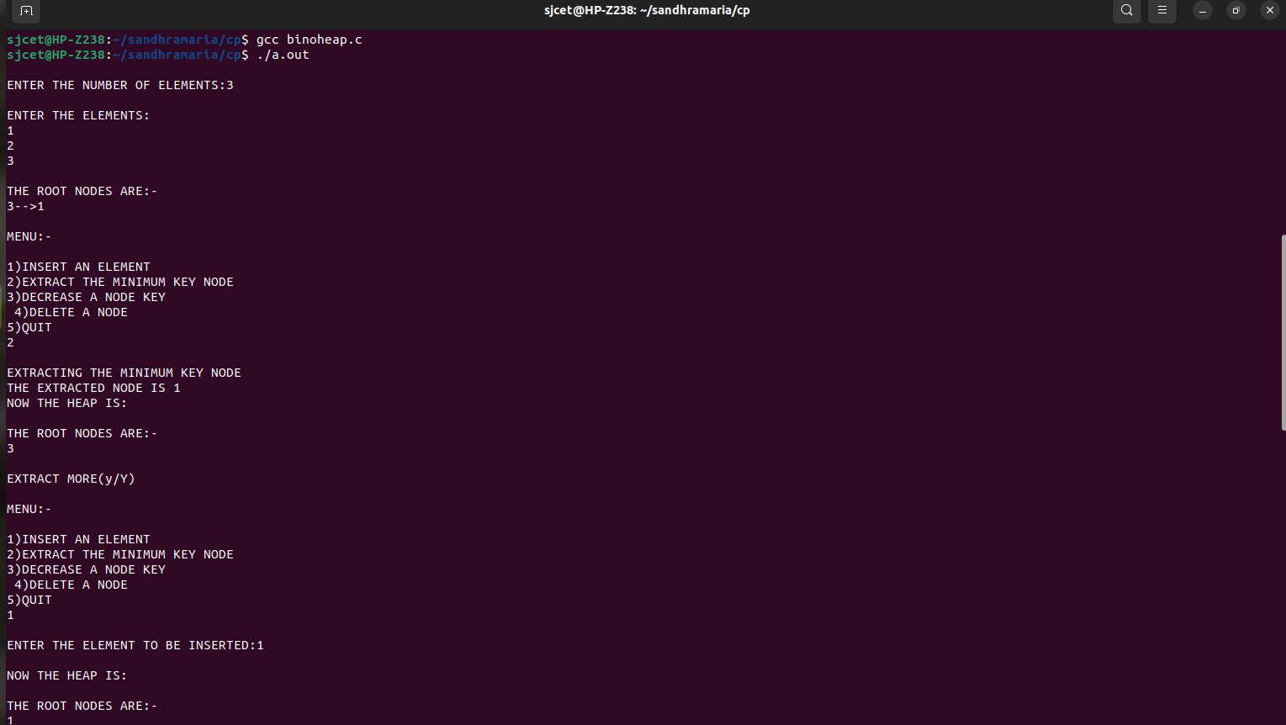

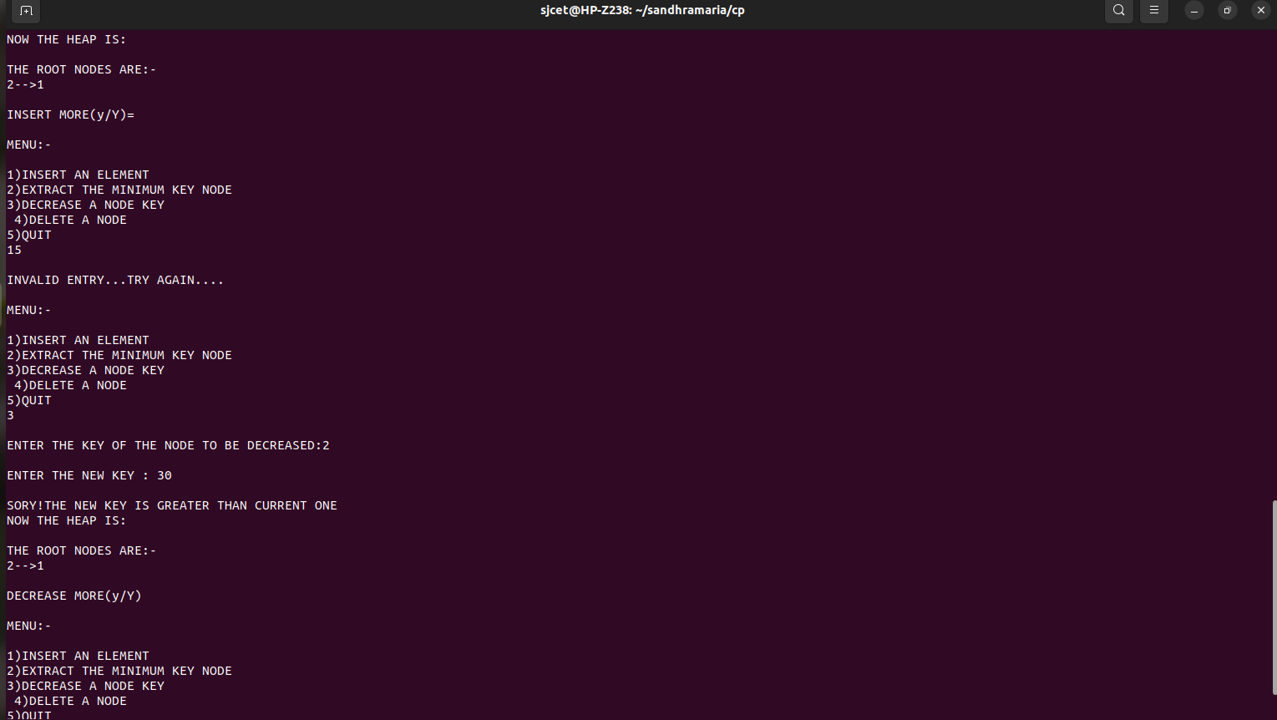

***21. Min Heap implementation***

#include <stdio.h>

#define HEAP_CAPACITY 10

#define SUCCESS_VAL 99999

#define FAIL_VAL -99999

int size = 0;

int i;

int heap[HEAP_CAPACITY];

void swap(int *a,int *b)

{

int temp = *b;

*b = *a;

*a = temp;

}

void heapify(int i)

{

if (size == 1)

{

return;

}

else{

int smallest = i;

int left = 2 * i + 1;

int right = 2 * i + 2;

if(left < size && heap[left] < heap[smallest])

smallest = left;

if(right < size && heap[right] < heap[smallest])

smallest = right;

if (smallest != i)

{

swap(&heap[i], &heap[smallest]);

heapify(smallest);

}

}

}

int insert(int newNum)

{

if(size==0)

{

heap[0] = newNum;

size += 1;

return SUCCESS_VAL;

}

else if(size < HEAP_CAPACITY)

{

heap[size] = newNum;

size += 1;

for(i =(size-1)/2;i>=0;i--)

{

heapify(i);

}

return SUCCESS_VAL;

}

else

{

printf("Heap capacity reached. Insertion failed.\n");

return FAIL_VAL;

}

}

int delete(int number)

{

int i,index=-1;

if(size <=0)

{

printf("Empty min heap");

return FAIL_VAL;

}

for(i=0;i<size;i++)

{

if(number == heap[i])

{

index = i;

break;

}

}

if(index == -1)

{

printf("Key is not found\n");

return FAIL_VAL;

}

swap(&heap[i],&heap[size-1]);

size -= 1;

for(i=(size-1)/2; i>=0;i--)

{

heapify(i);

}

return SUCCESS_VAL;

}

void printHeap()

{

for( i=0;i<size;++i)

{

if(i==0)

printf("%d(root) ", heap[i]);

else

printf("%d(%d's child) ",heap[i],heap[(i-1)/2]);

}

printf("\n");

}

int main()

{

while(1)

{

printf("\n___MENU___\n1.Insert Element \n2.Print MinHeap \n3.Delete Element \n4.Exit \n");

int choice;

scanf("%d",&choice);

if(choice==1)

{

printf("Enter the element to be inserted\n");

int item;

scanf("%d",&item);

int res=insert(item);

if(res==SUCCESS_VAL)

printf("inserted successfully\n");

}

else if(choice==2)

{

printHeap();

}

else if(choice==3)

{

int res = delete(heap[0]);

if(res==SUCCESS_VAL)

printf("Delete Successfully\n");

else

printf("Deleted Unsuccessfully\n");

}

else if(choice==4)

{

break;

}

}

}

￼￼

￼

***22.Implementation Of prim's algorithm***

#include<stdio.h>

#include <string.h>

#include<stdbool.h>

#define INF 9999999

#define V 5

int G[V][V] = {

{0, 9, 75, 0, 0},

{9, 0, 95, 19, 42},

{75, 95, 0, 51, 66},

{0, 19, 51, 0, 31},

{0, 42, 66, 31, 0}};

int main()

{

int no_edge; // number of edge

int selected[V];

memset(selected, false, sizeof(selected));

no_edge = 0;

selected[0] = true;

int x;

int y;

printf("Edge : Weight\n");

while (no_edge < V - 1)

{

int min = INF;

x = 0;

y = 0;

for (int i = 0; i < V; i++)

{

if (selected[i])

{

for (int j = 0; j < V; j++)

{

if (!selected[j] && G[i][j])

{

if (min > G[i][j]) {

min = G[i][j];

x = i;

y = j;

}

}

}

}

}

printf("%d - %d : %d\n", x, y, G[x][y]);

selected[y] = true;

no_edge++;

}

return 0;

}

